**Name : Đinh Gia Bảo**

**Student ID: SE183741**

LAB1: Installing the Fedora OS on   
a Virtual Machine

**Requirement**

1. Capture all windows for showing that you installed successfully the Fedora, MC, Fedora Eclipse
2. Demonstrate 2 programs in the guiding tutorial to file (PDF format is recommended) and upload it to the CMS. You must give an explanation to the program 1 about processes.

**Download latest VMWare Station:** [https://www.vmware.com/content/vmware/vmwarepubli shed-sites/us/products/workstationplayer.html.html](https://www.vmware.com/content/vmware/vmwarepubli%20shed-sites/us/products/workstationplayer.html.html)

**Download your compatible Fedora version:** <https://fedoraproject.org/en/workstation/download/>

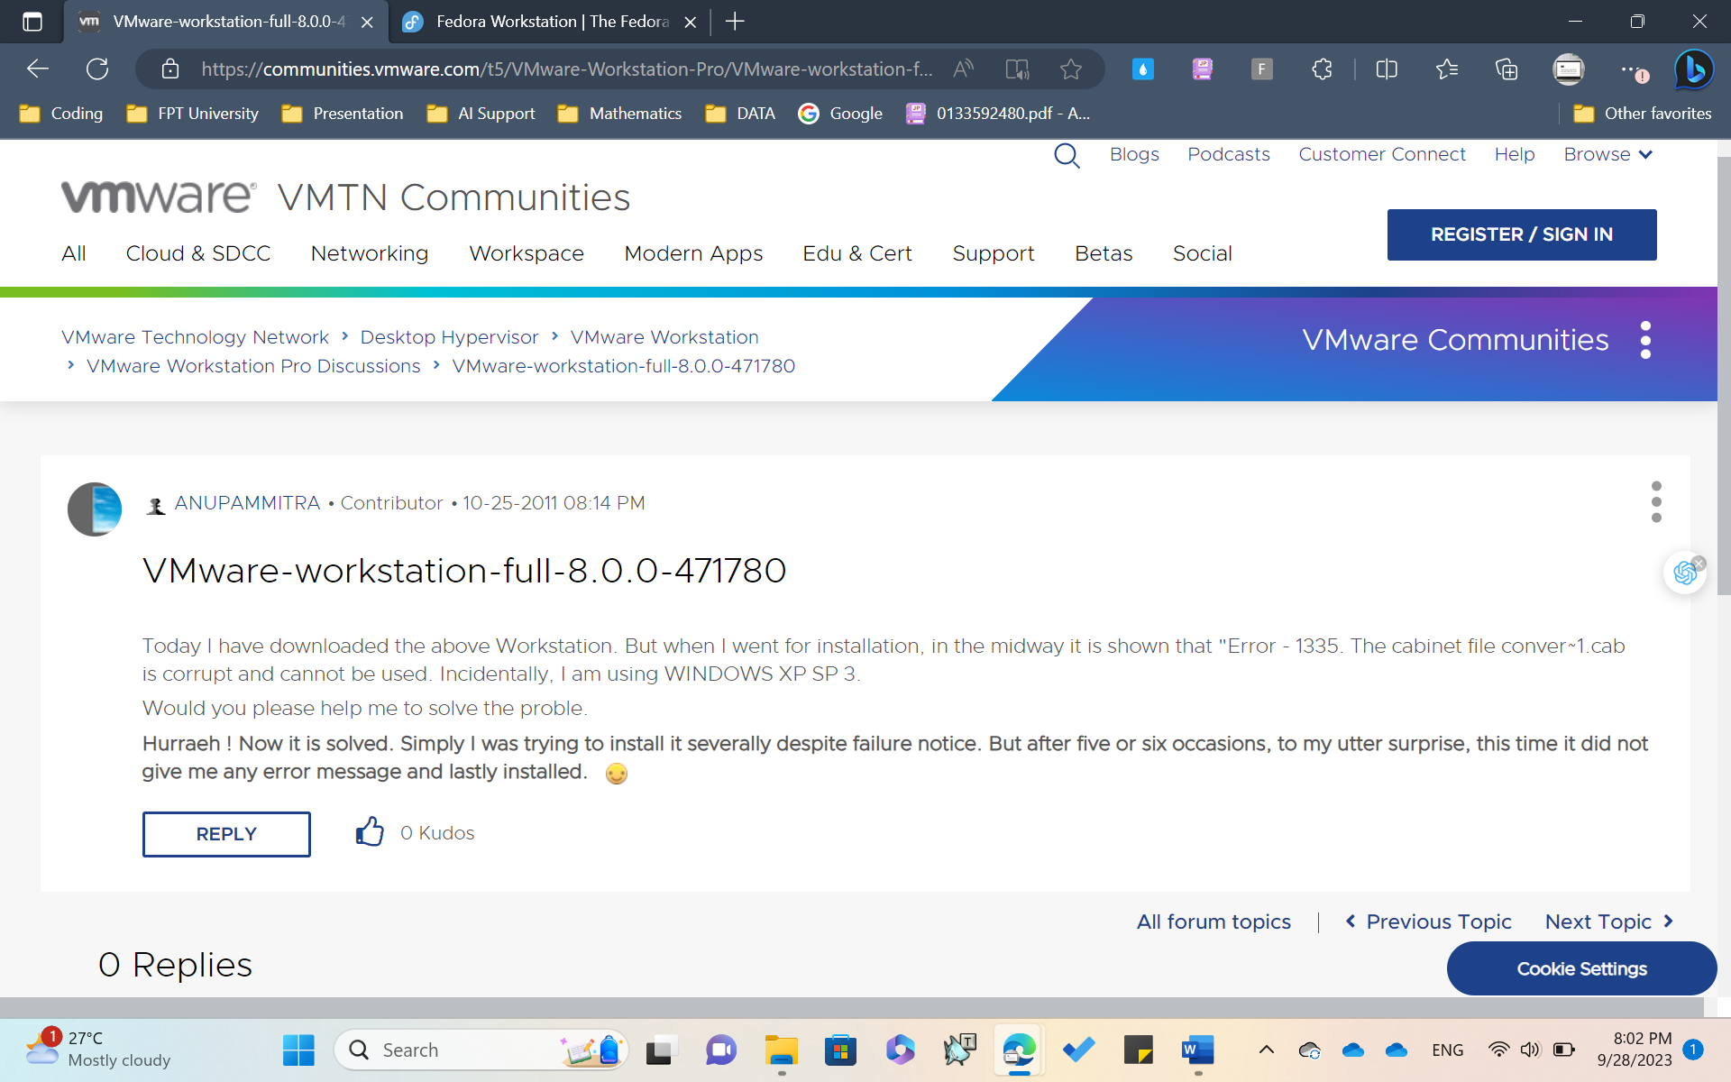

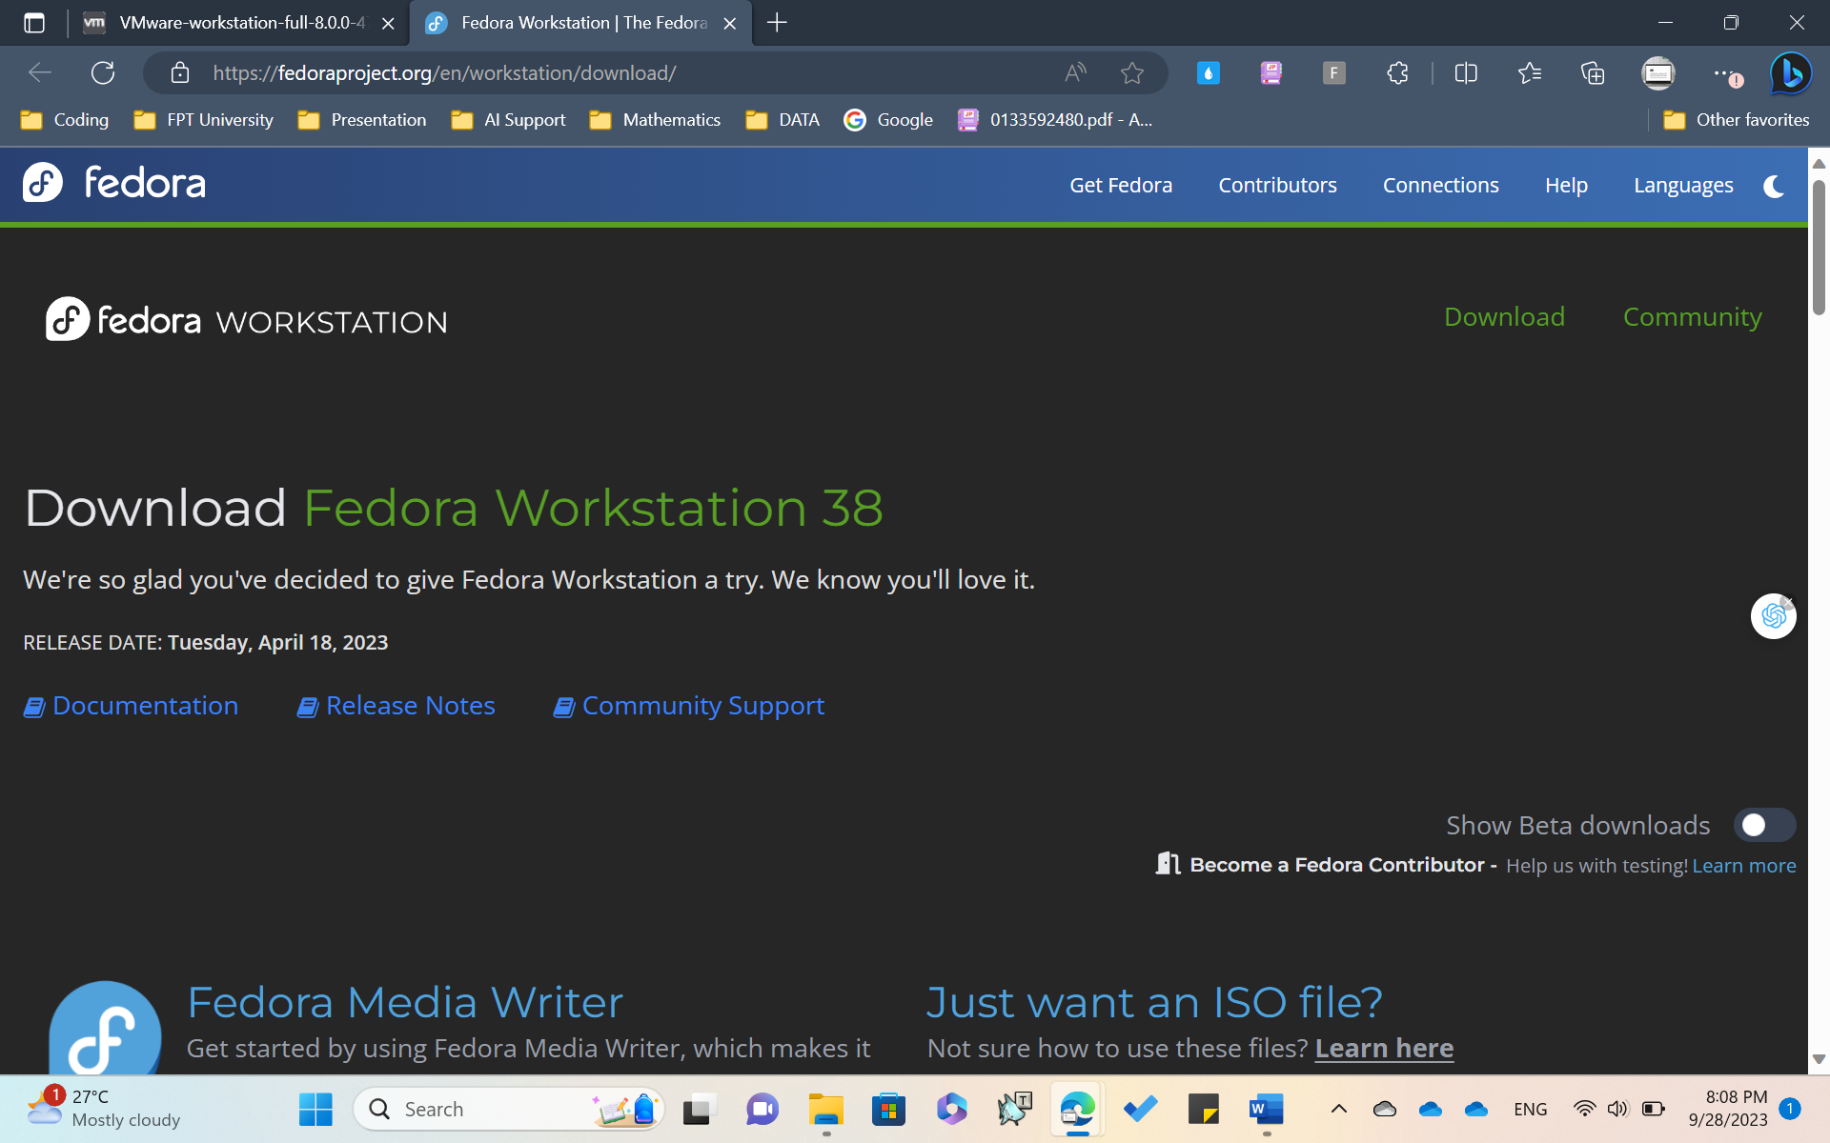

Download **VMWare Workstaion** and **Fedora Workstation on Website.**

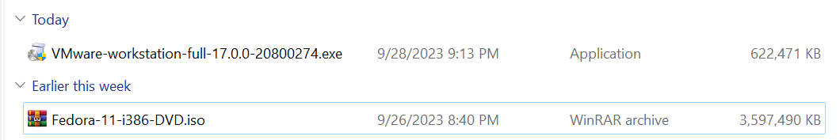

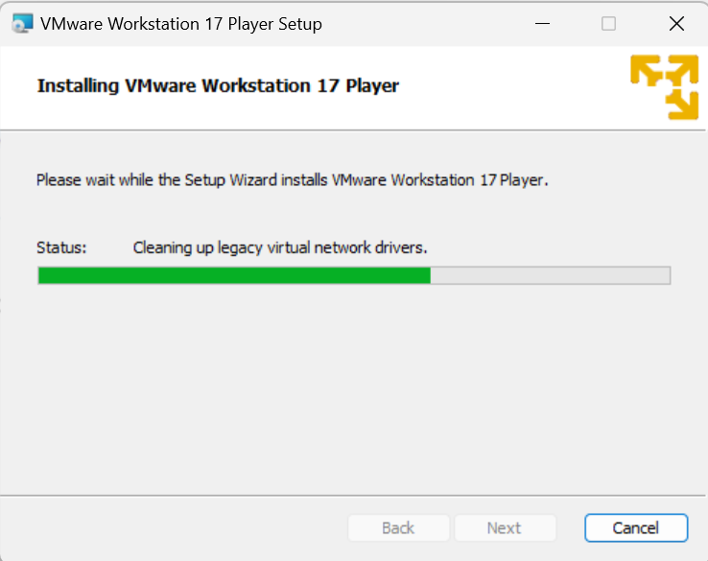

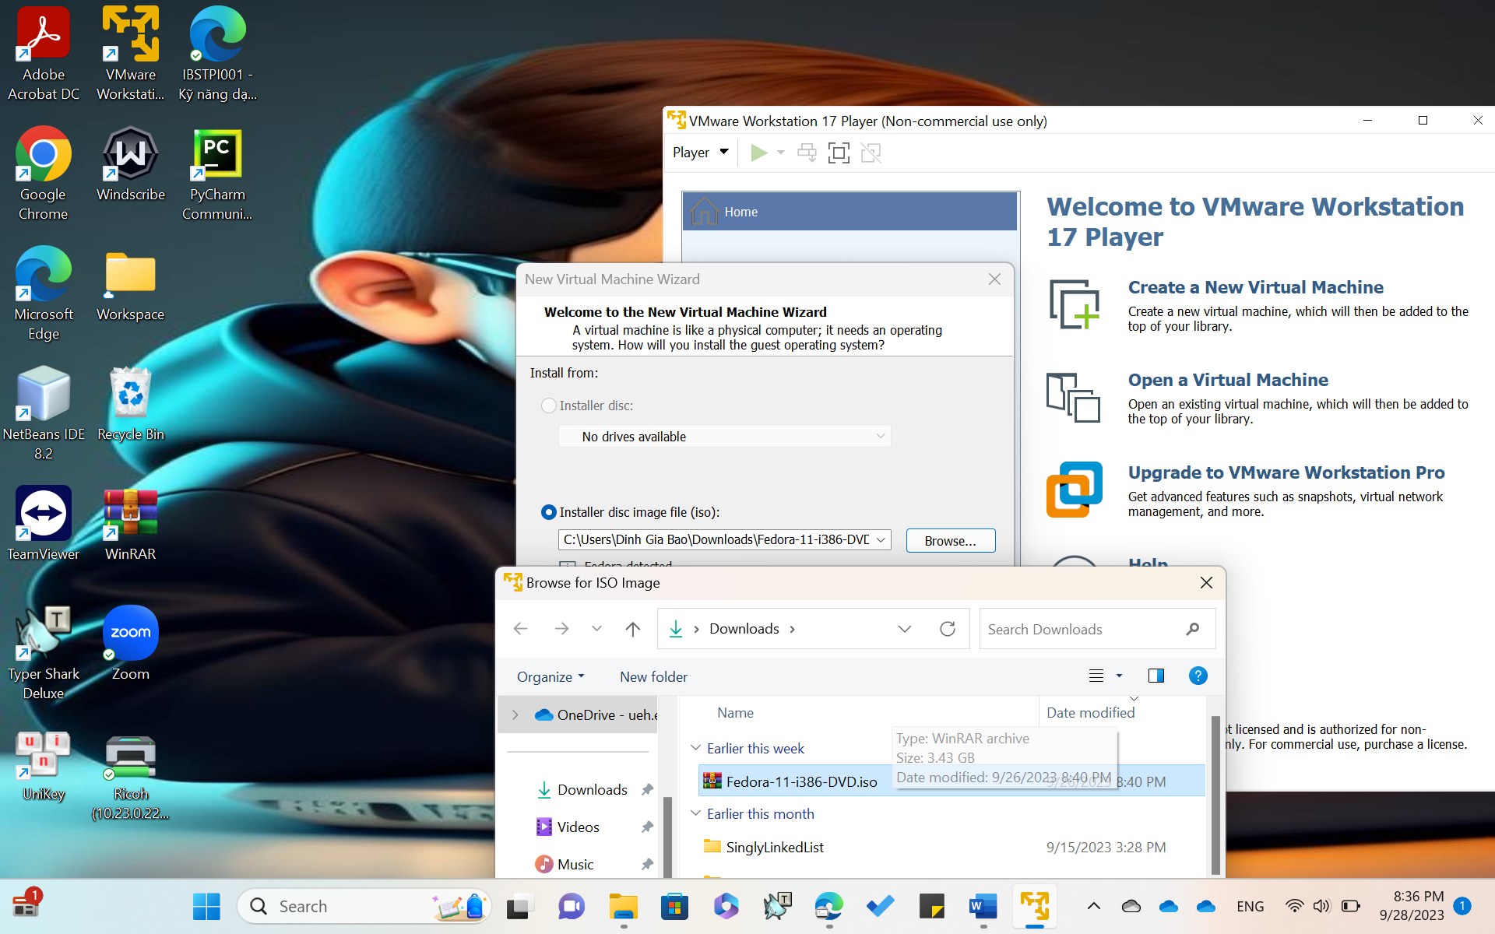

**Add Fedora file(.iso) to the New Virtual Machine setup.**

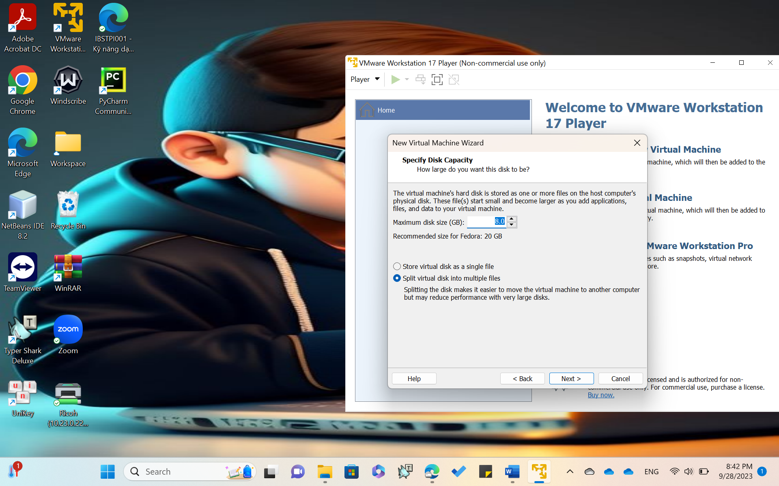

Specify the MAXIMUM Disk-size ( multiple of 2GB )

The **Split virtual disk into multiple files** should be selected.

**INSTALL FEDORA**

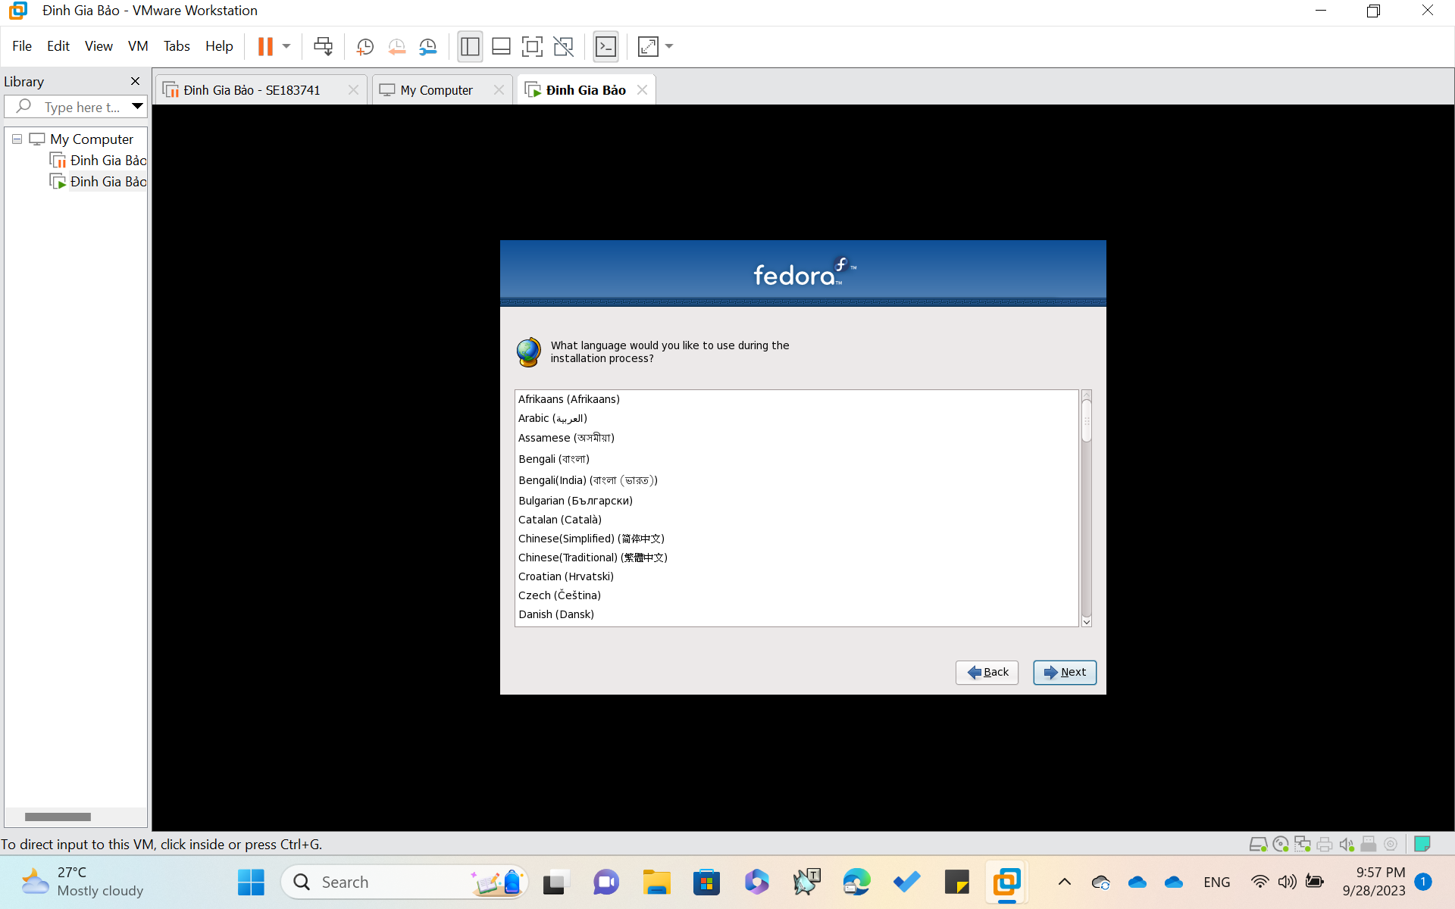

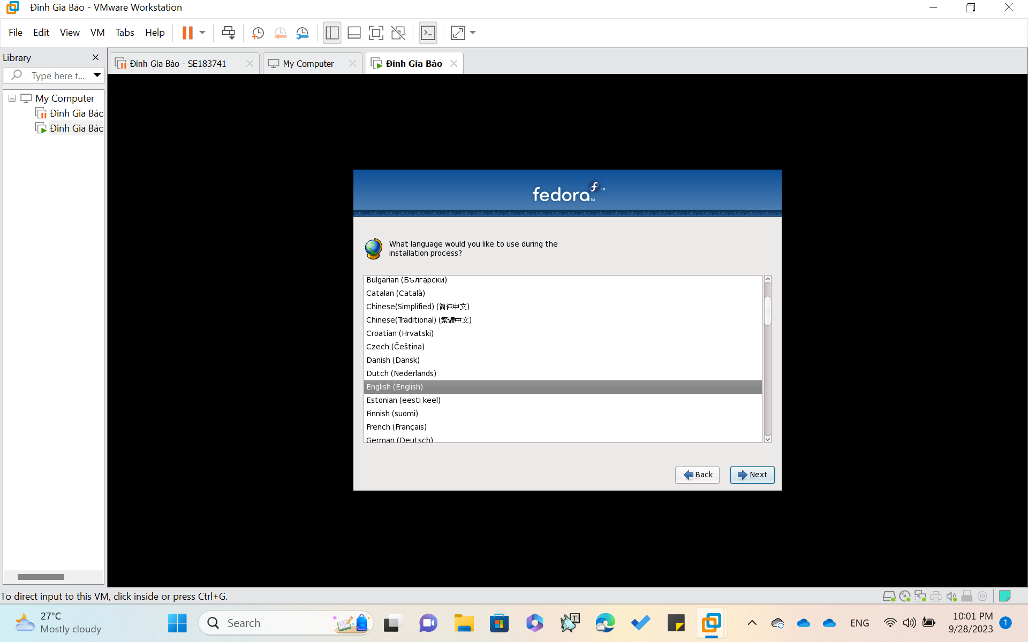

**Choose your Language**

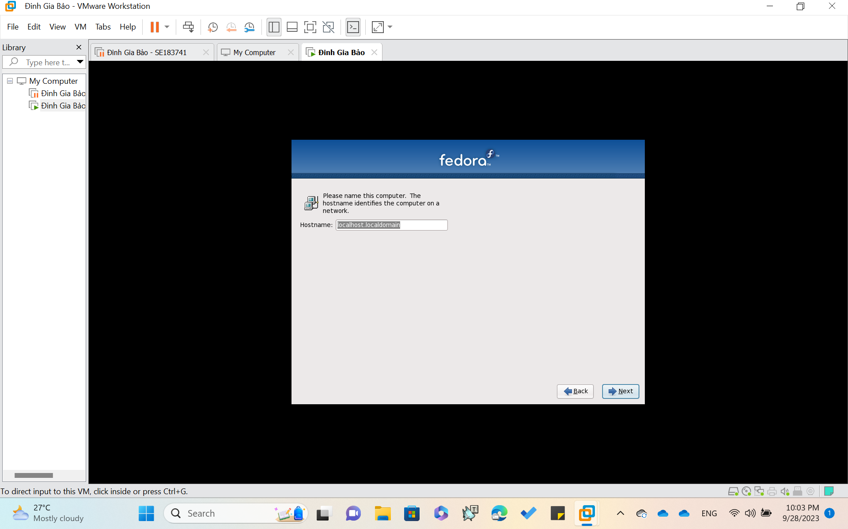

Click **NEXT** button

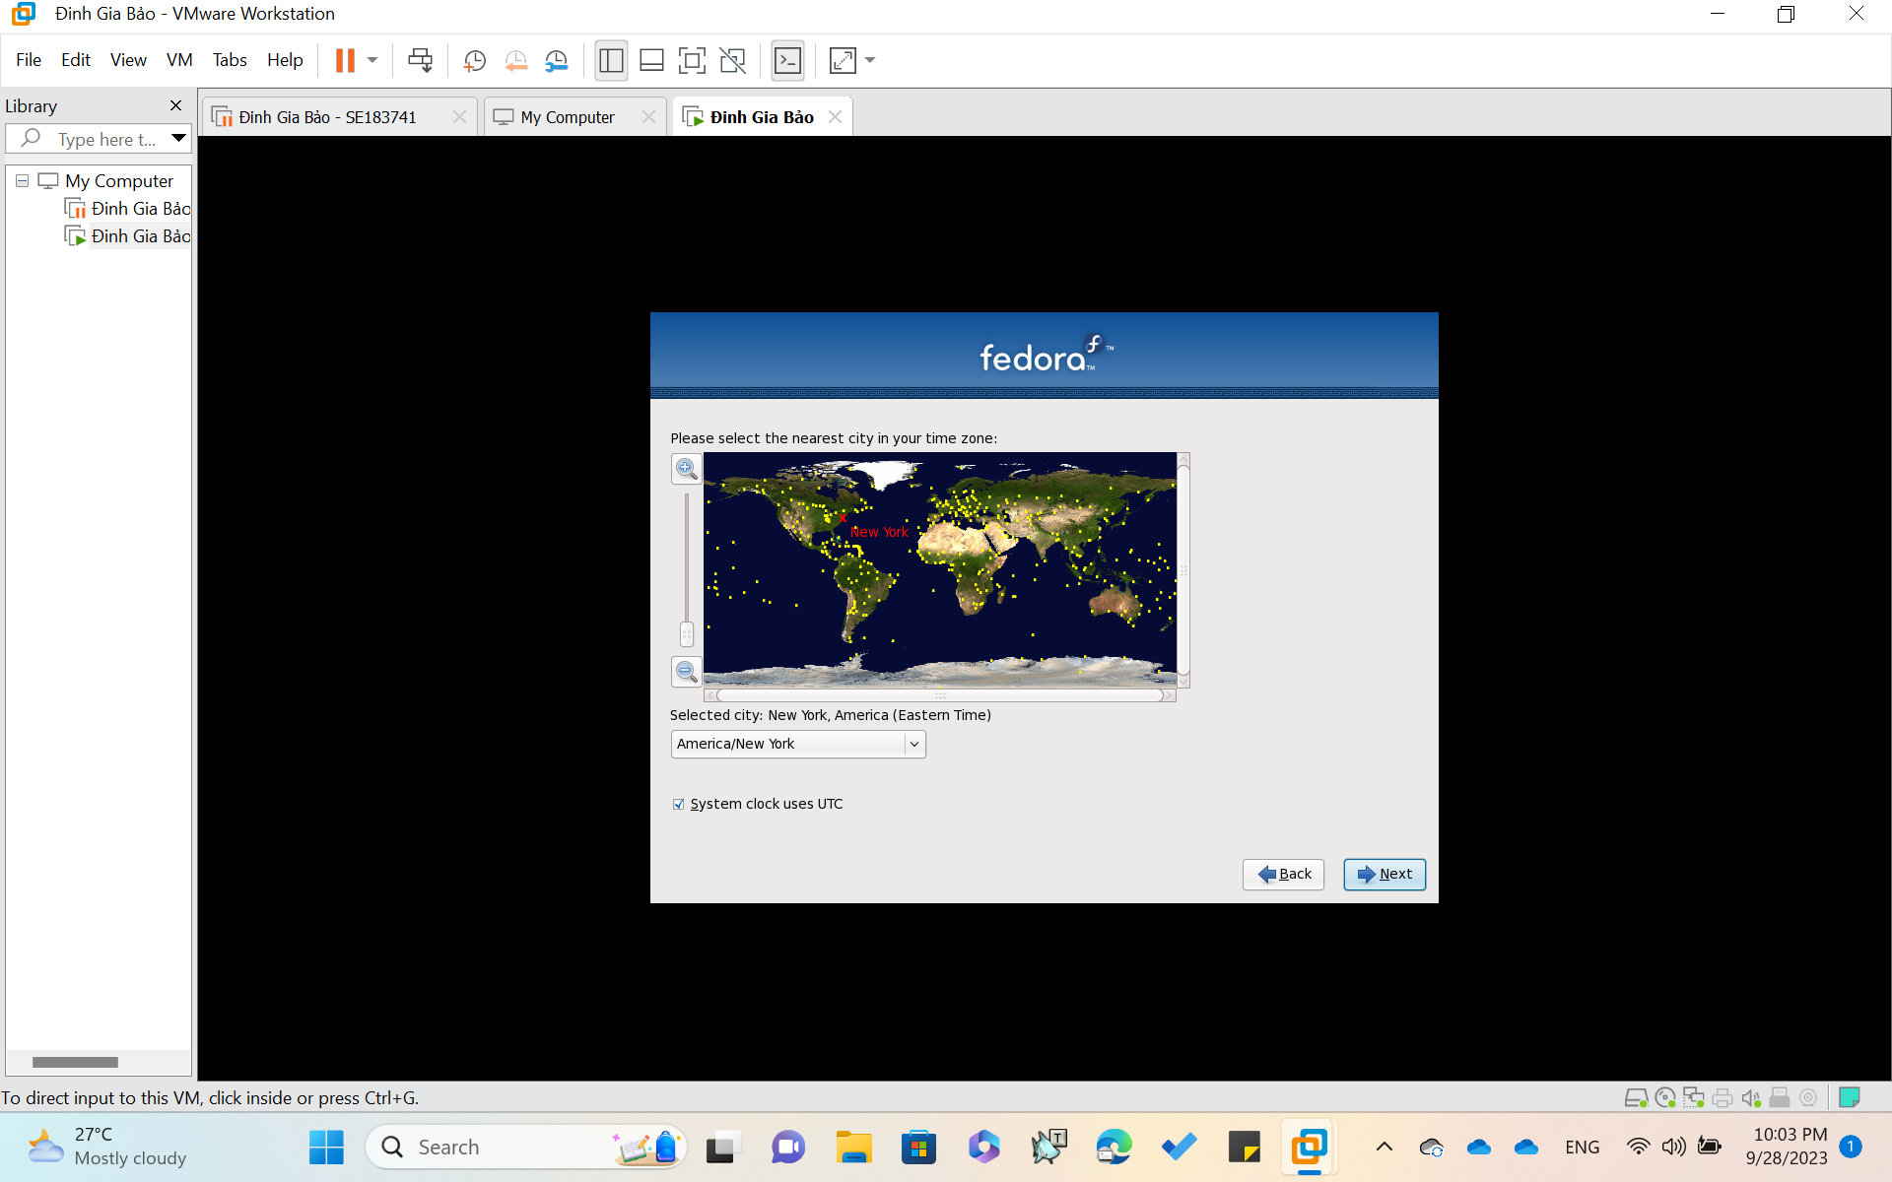

Click **Next**

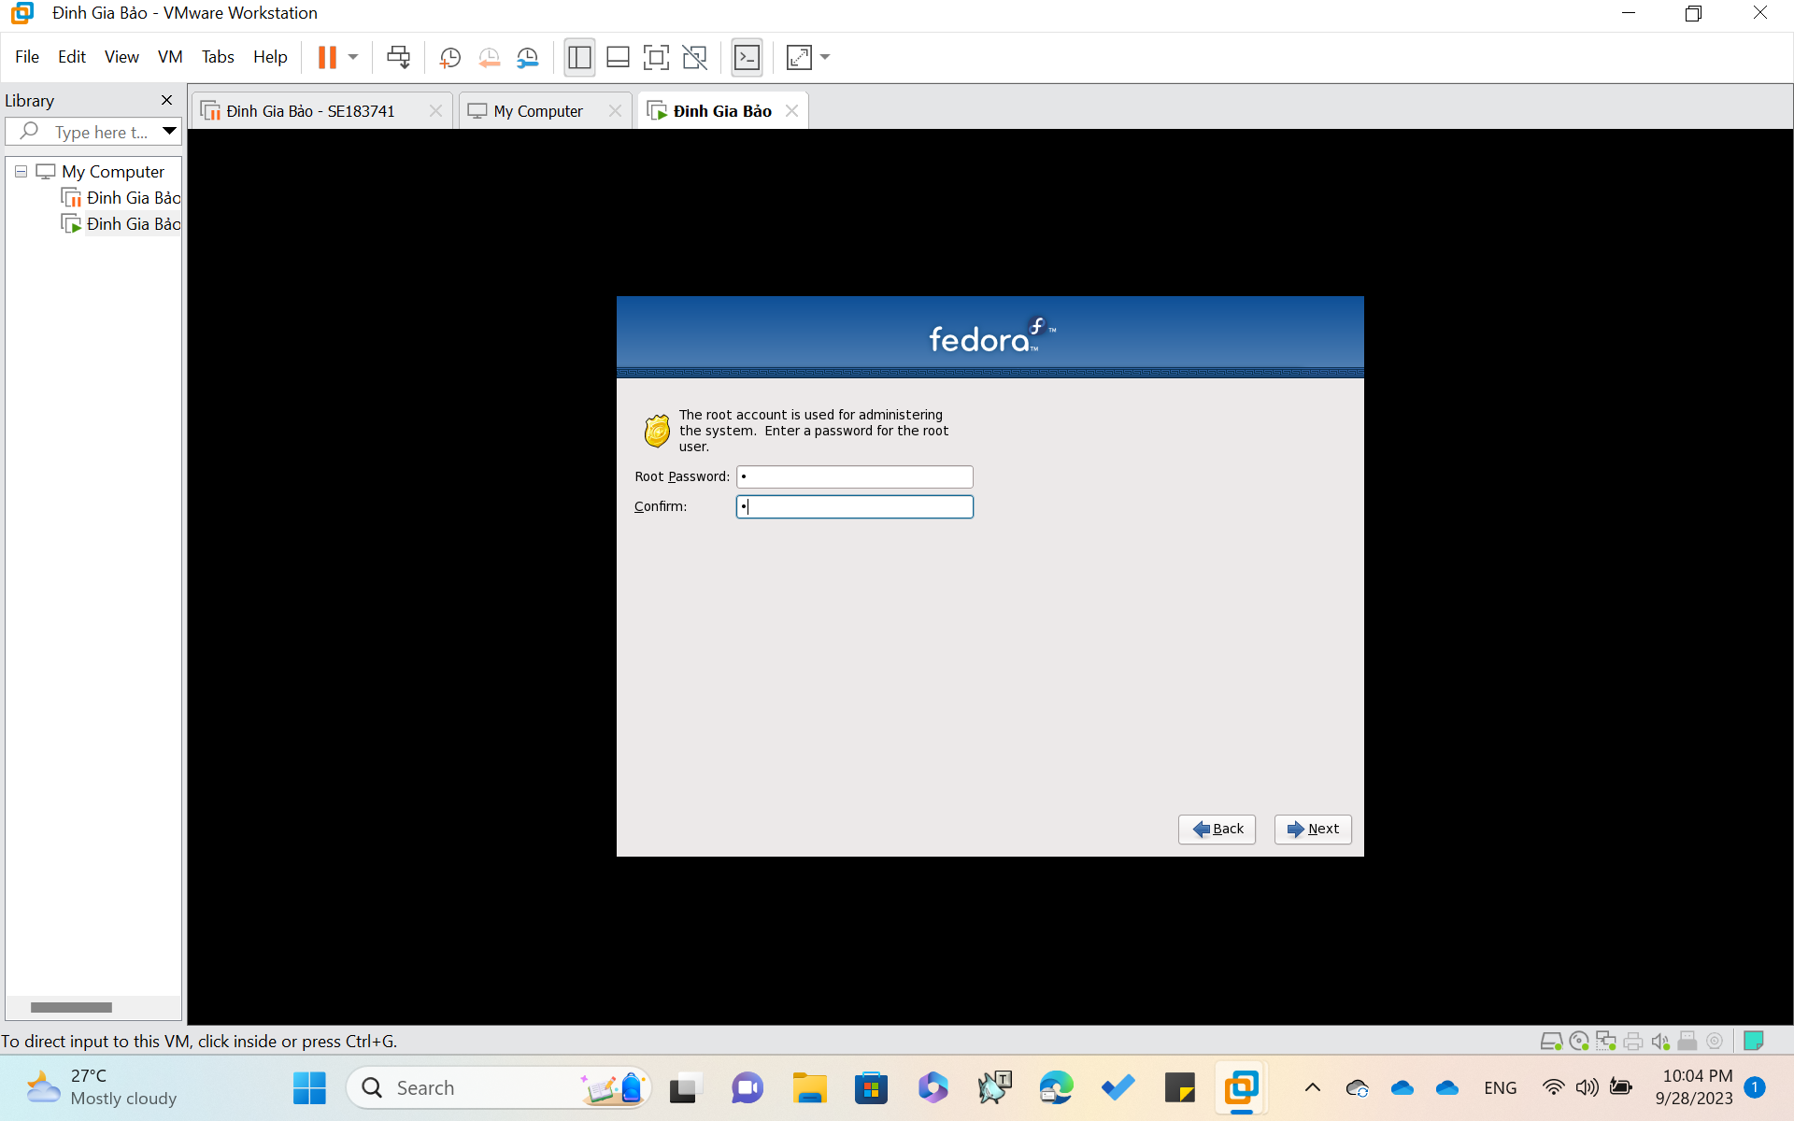

Set **Password** !!!

Recommend to Set your pasword as ‘ 1 ’

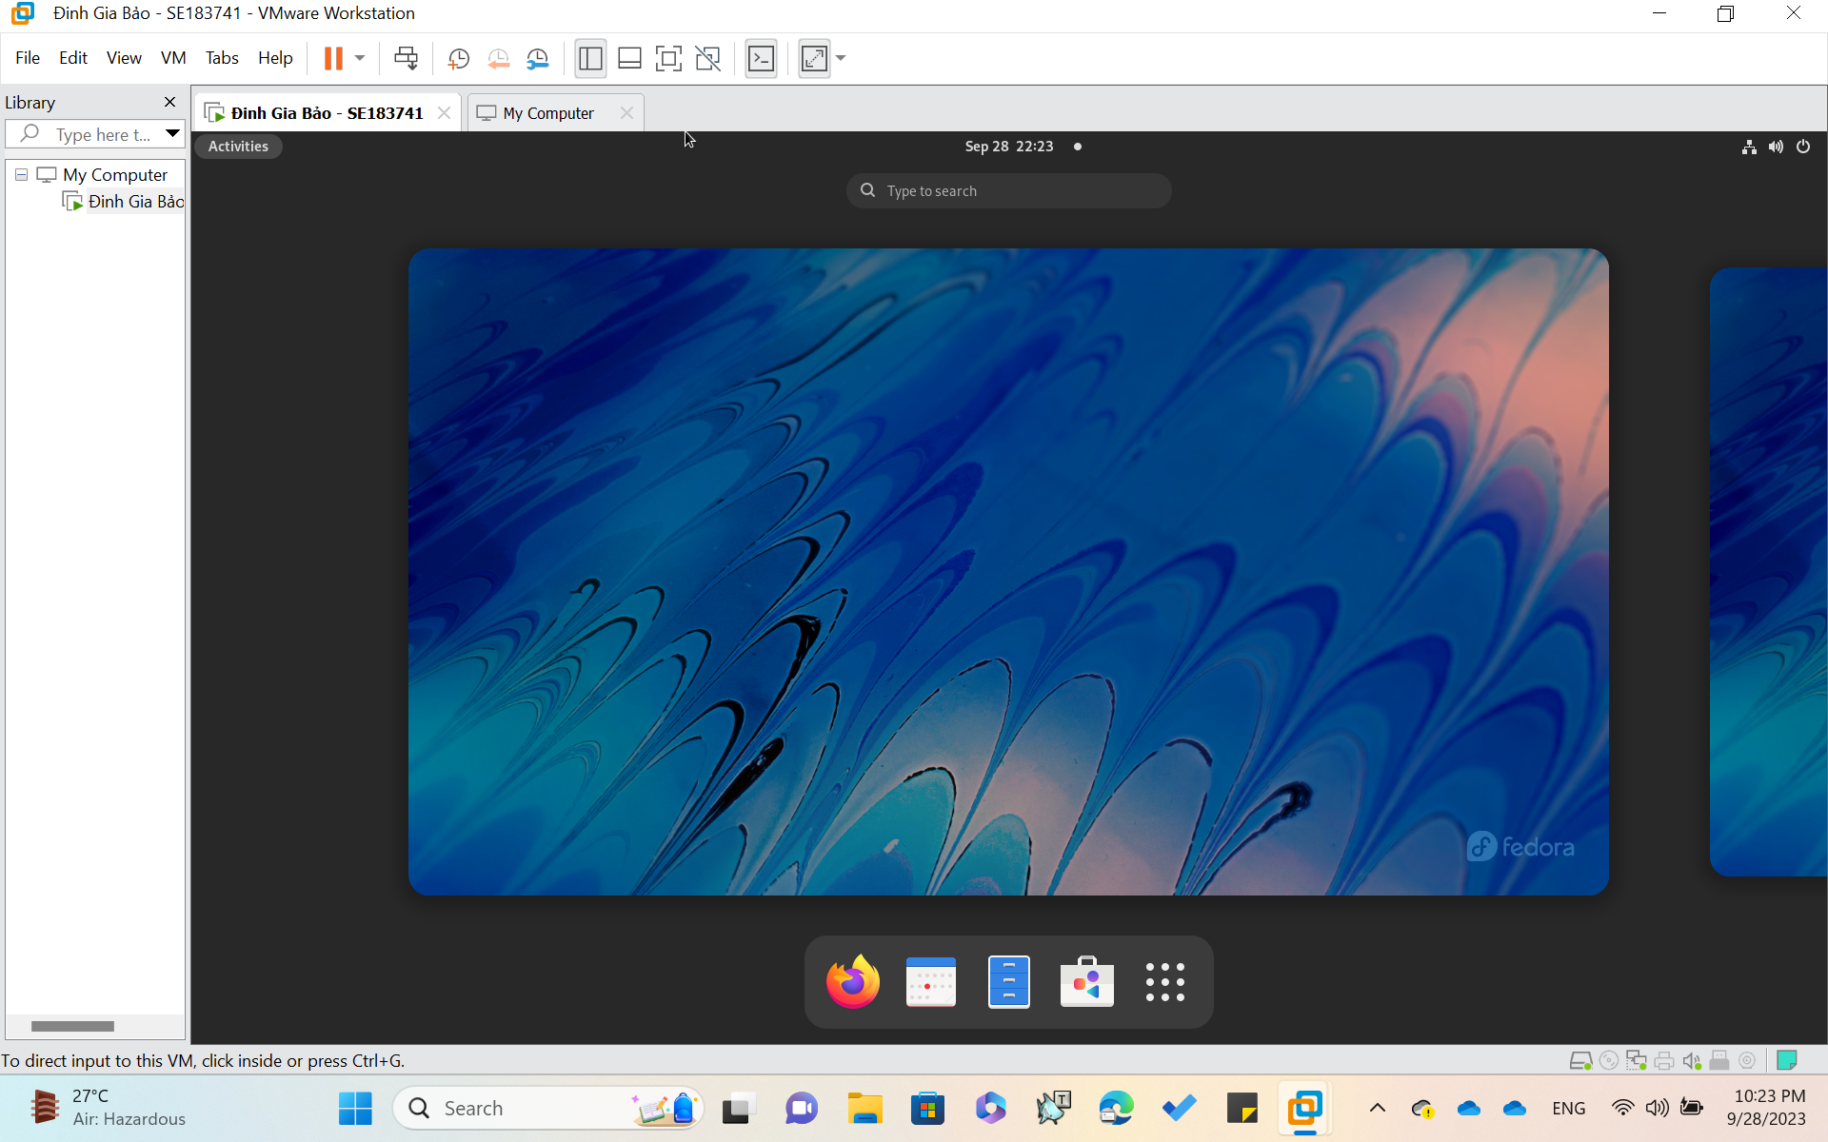

**HERE IS A FEDORA GUI**

**INSTALL Midnight Commander**

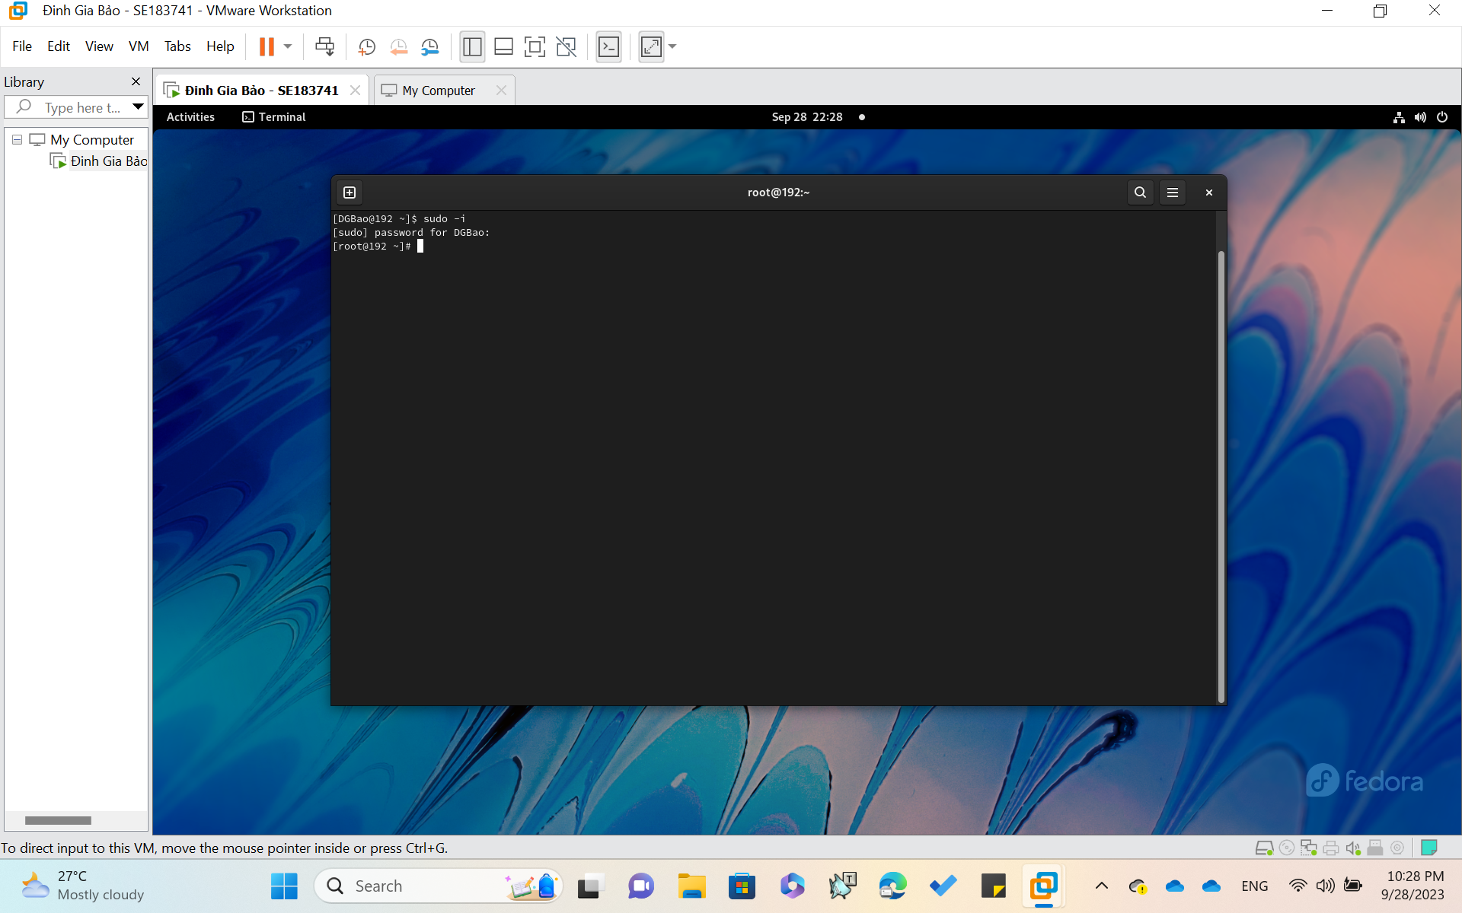

Open **Terminal** (in Activities) then type **sudo -i**

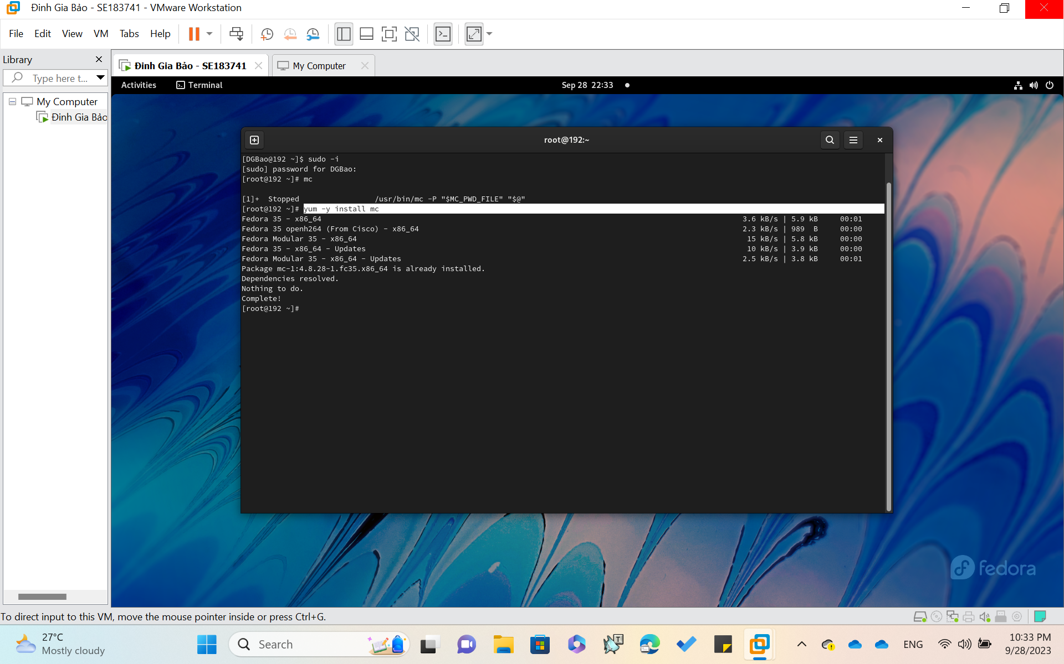

After enter correctly the **password**

Use the command ‘**yum -y install mc’**

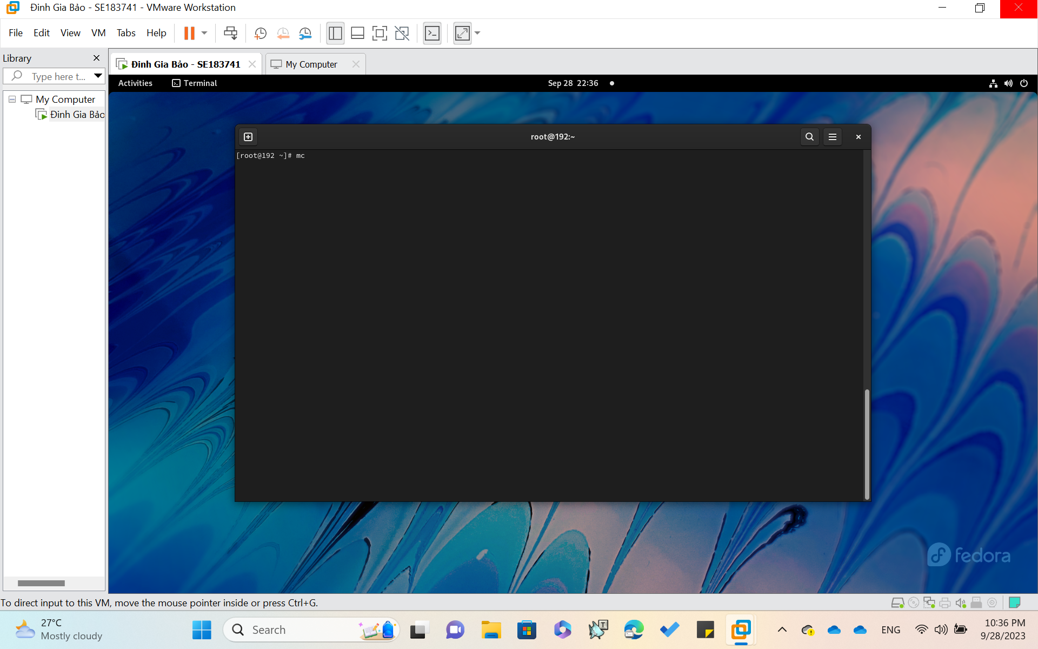

Type ‘**mc**’ to check **Midnight Commander**

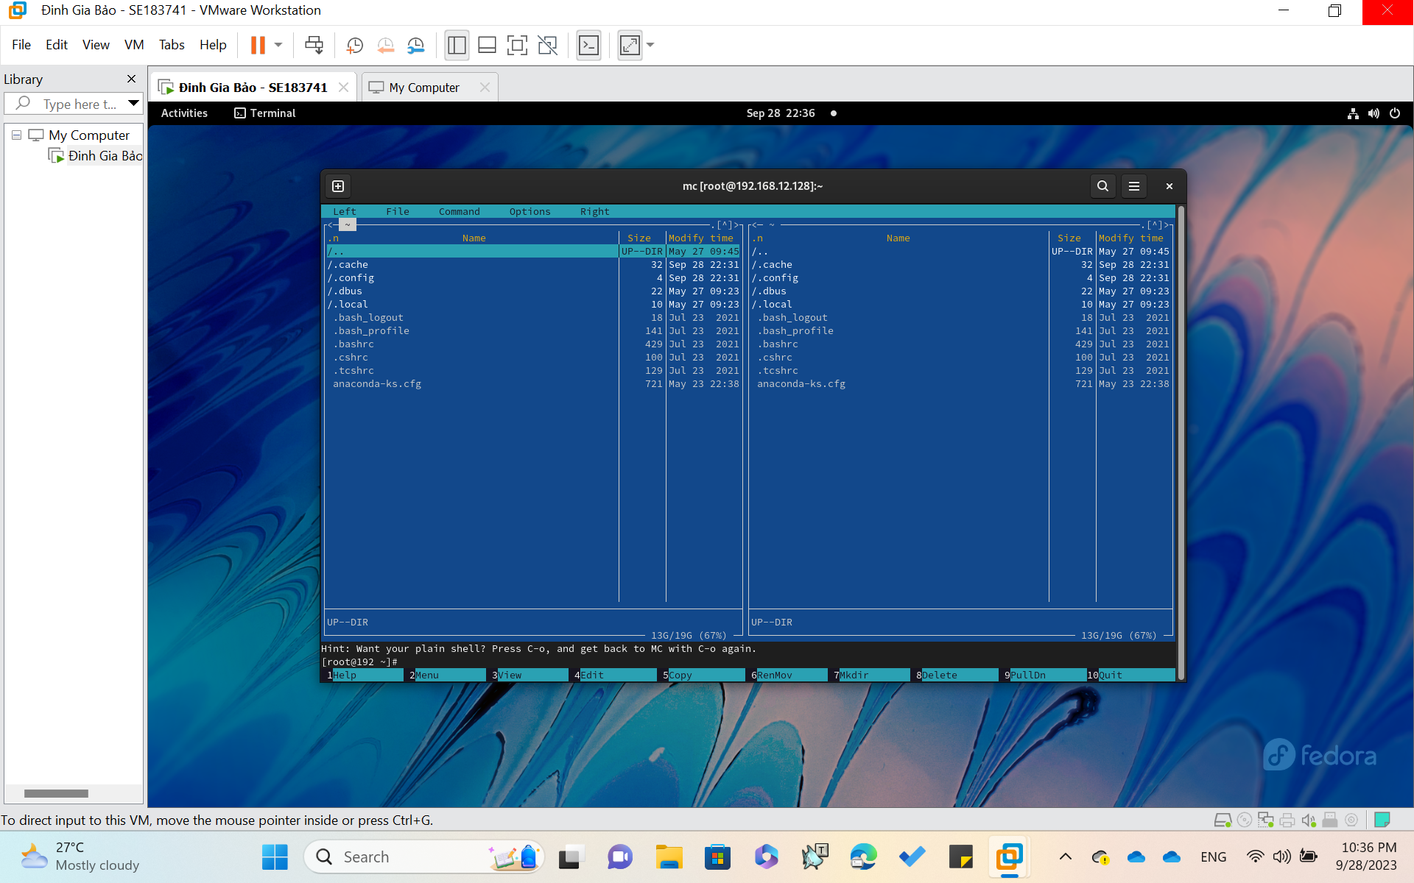

**Install and Use the Fedora Eclipse C/C++ .**

[Eclipse downloads - Select a mirror | The Eclipse Foundation](https://www.eclipse.org/downloads/download.php?file=/oomph/epp/2023-09/R/eclipse-inst-jre-linux64.tar.gz)

Use the link given above !!!

Firstly , Install C/C++ Environment in Terminal by Command **“sudo dnf** **install gcc-c++”**

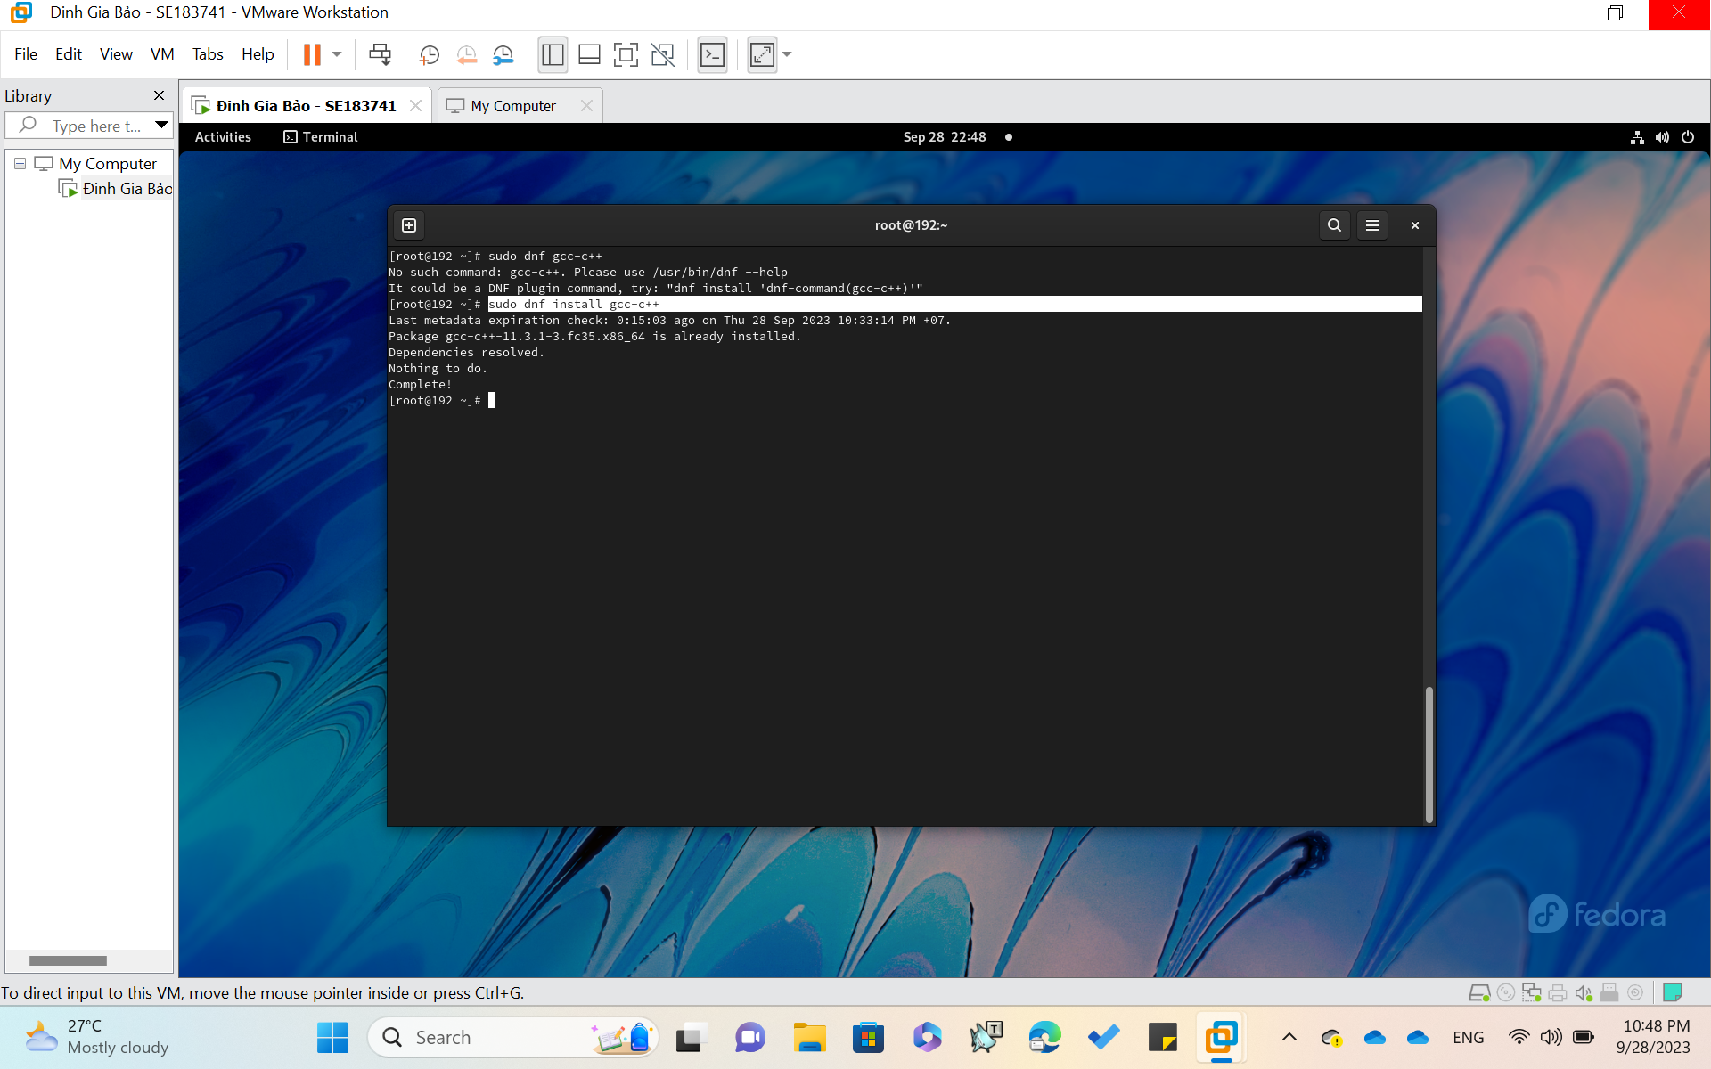

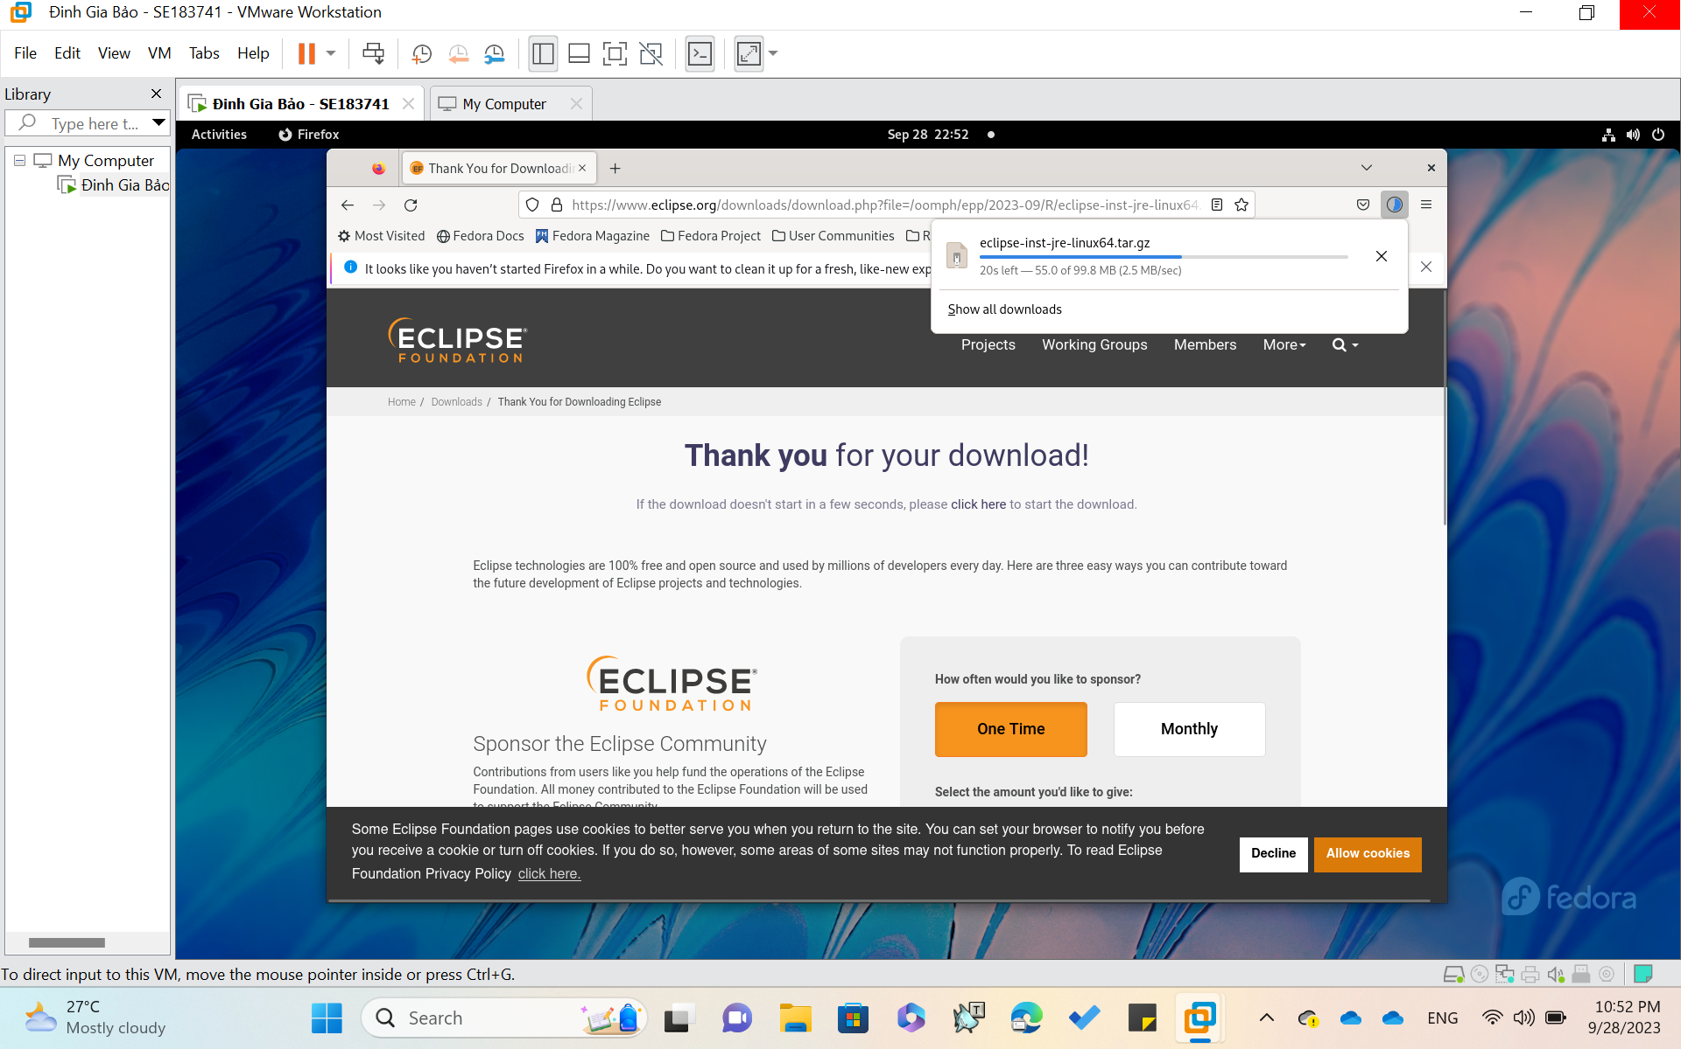

Download Eclipse with the link above . Copy it and paste it to Firefox on Fedora

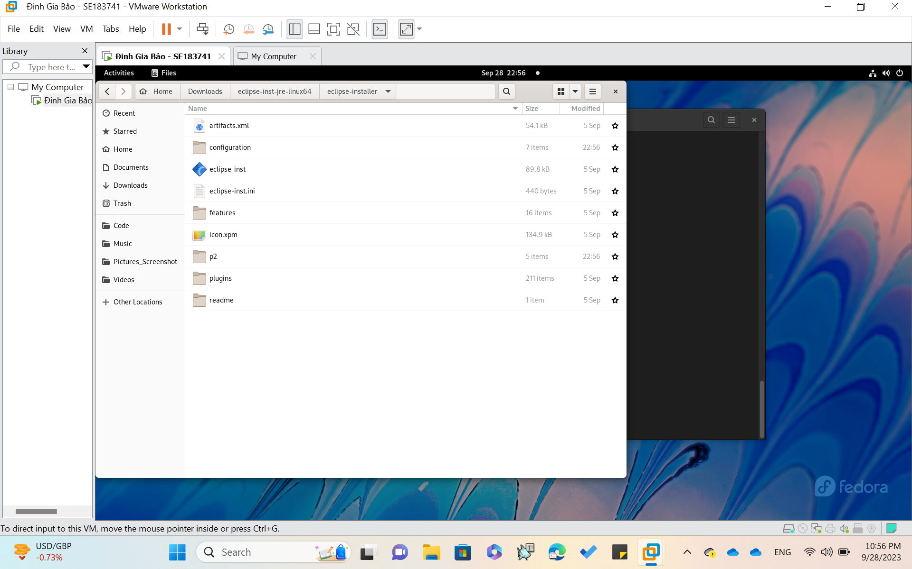

Click on the **‘eclipse-inst’**

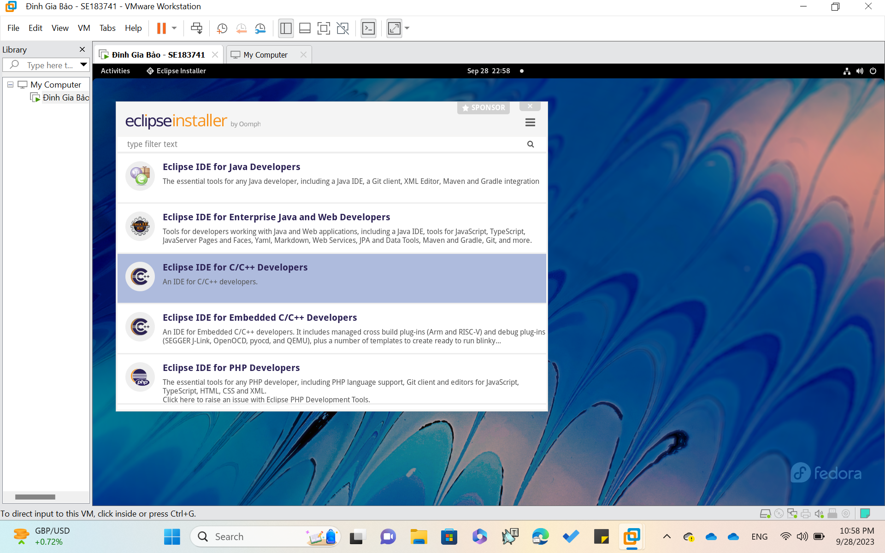

Choose ‘**Eclipse IDE for C/C++ Developers**’ and Click ‘**Install**’

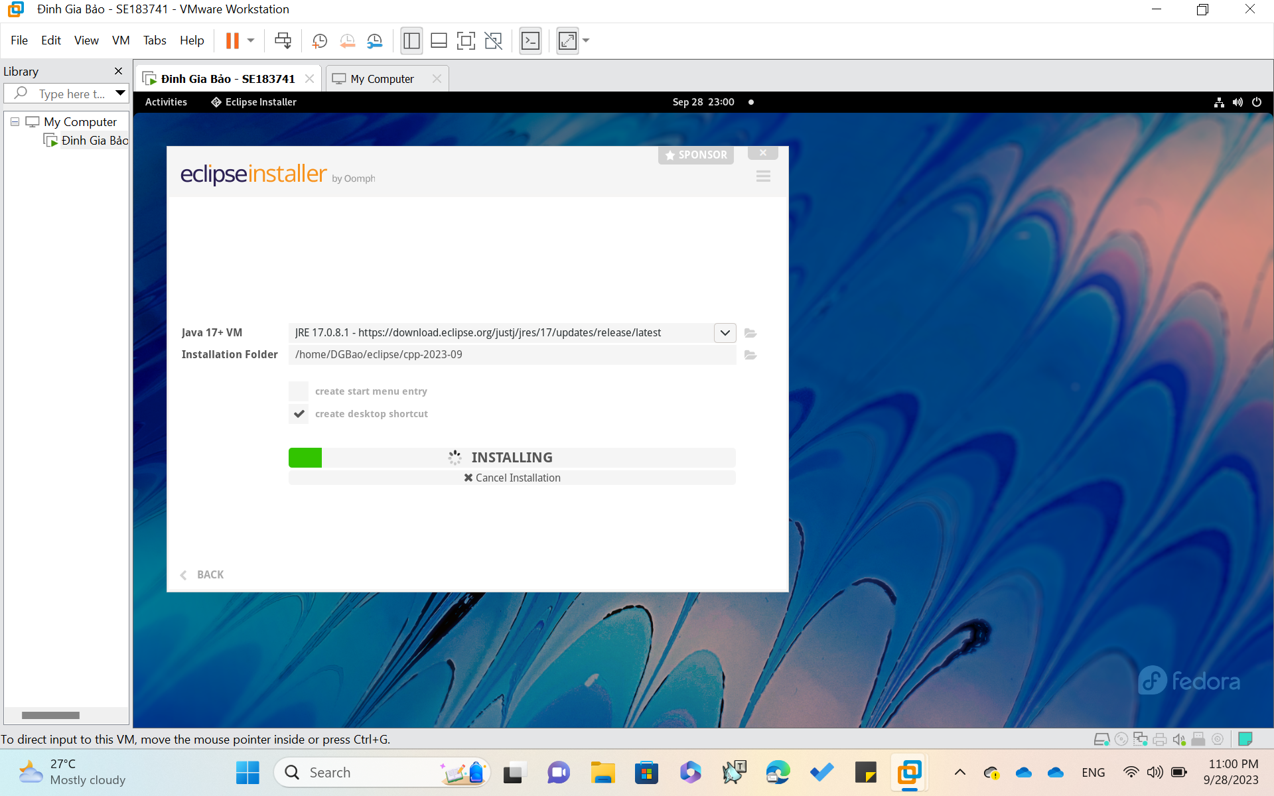

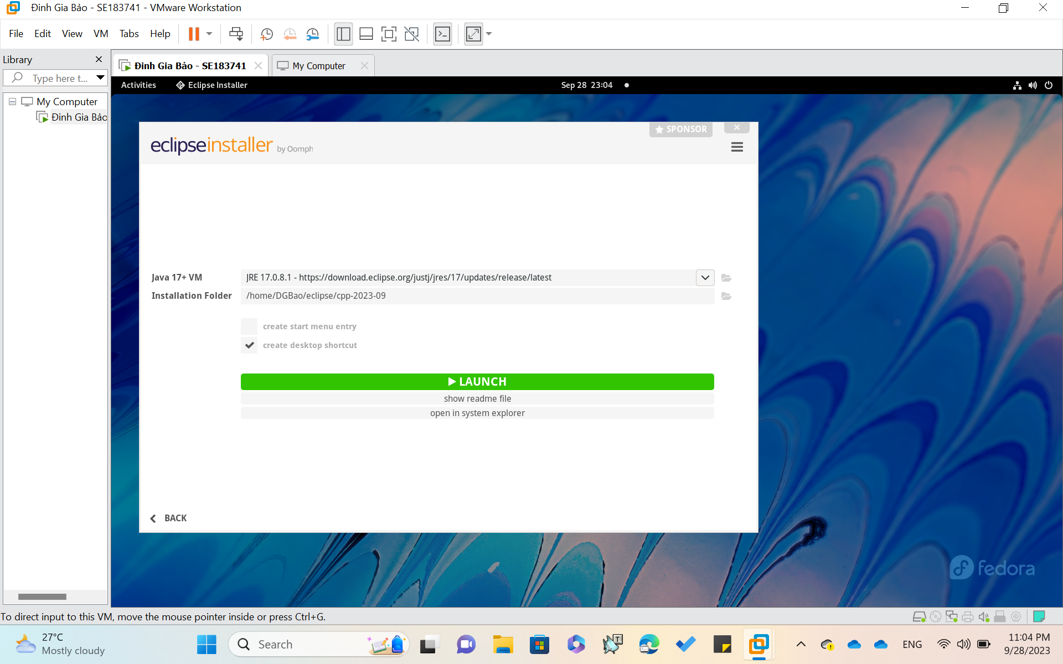

Download **SUCCESSFULLY**

Click **LAUNCH**

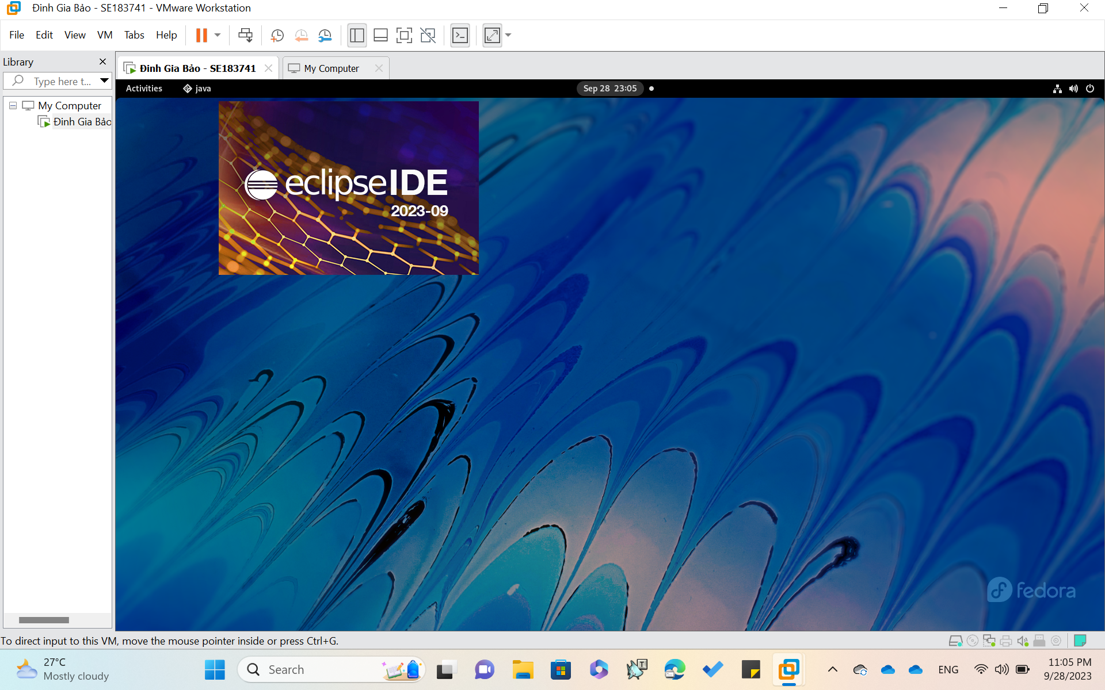

**CREATE A FIRST C/C++ PROJECT**

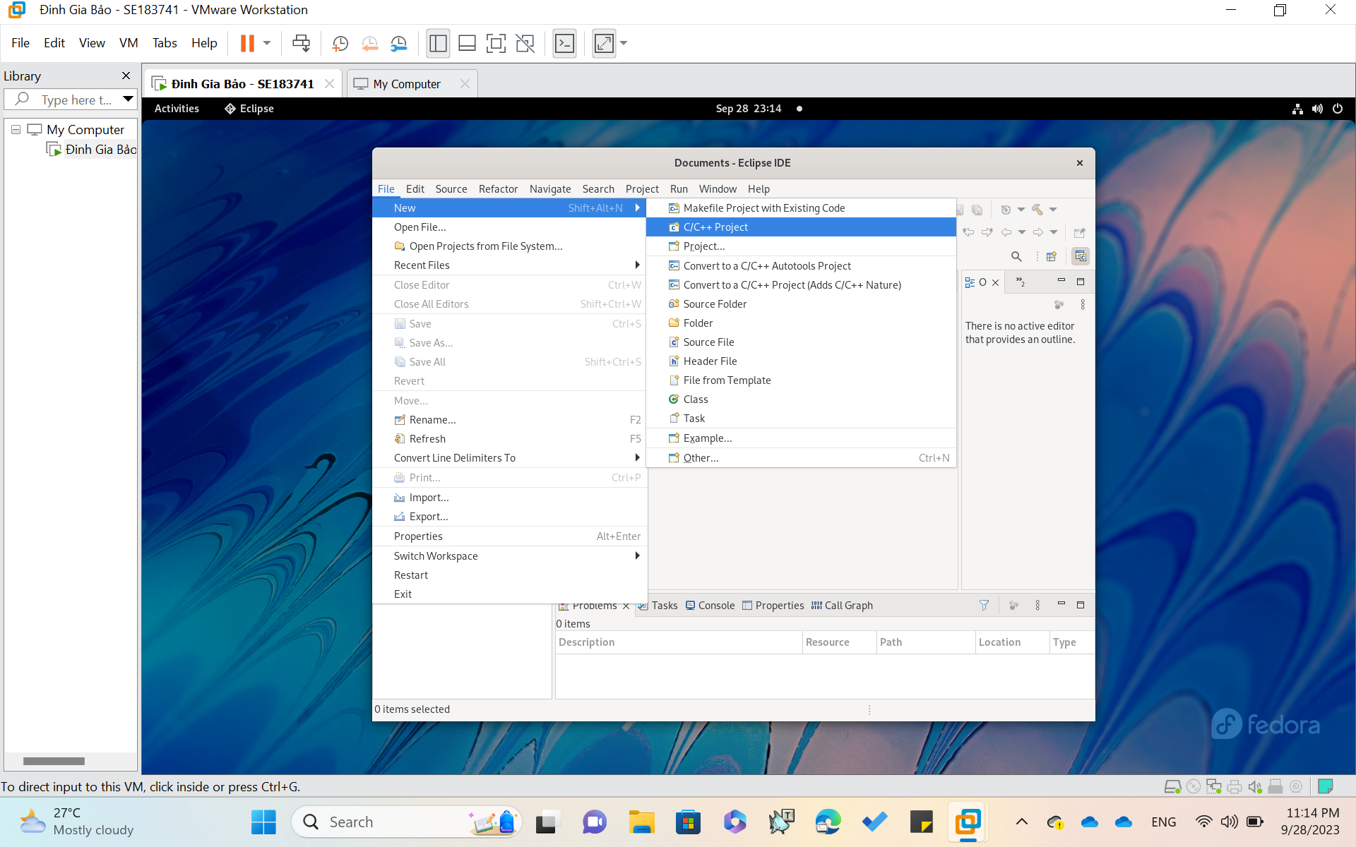

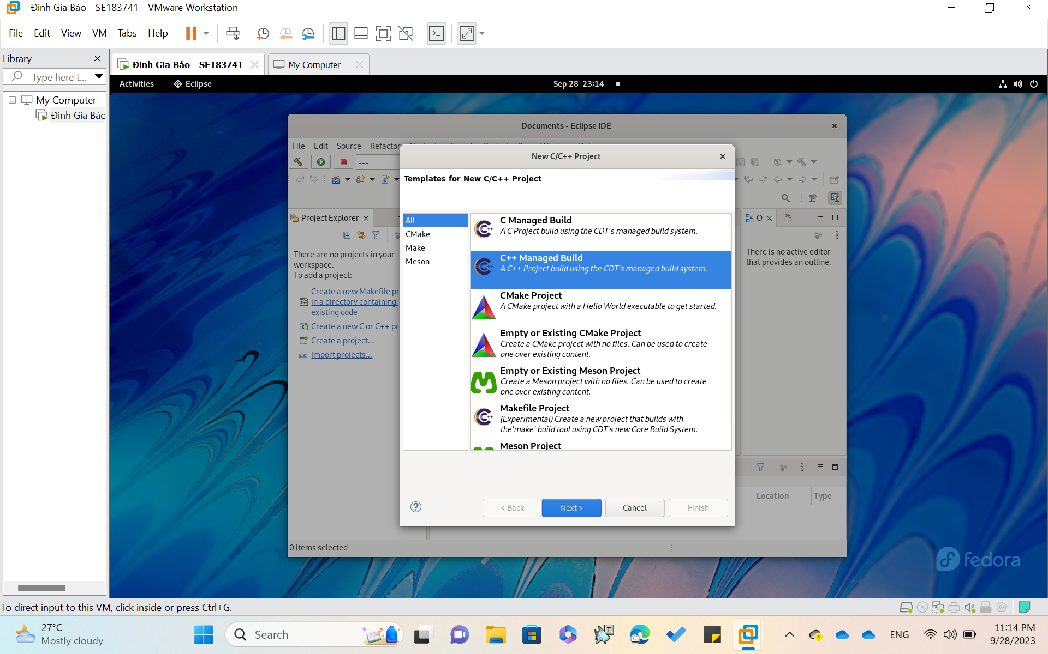

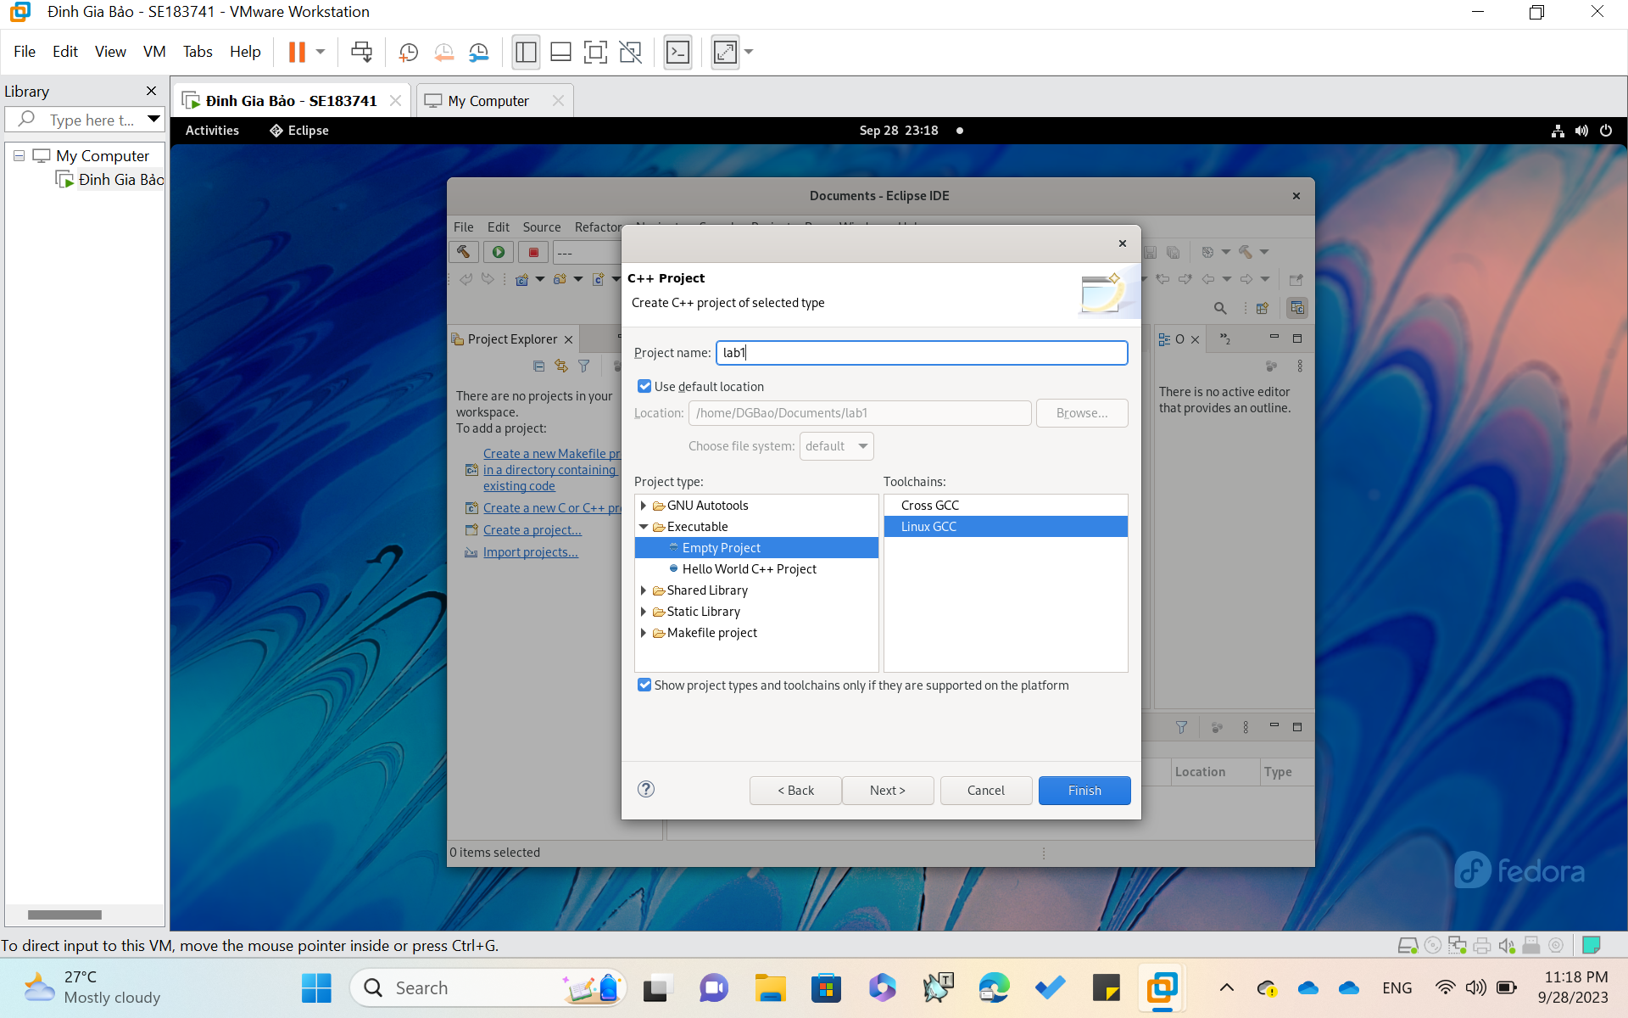

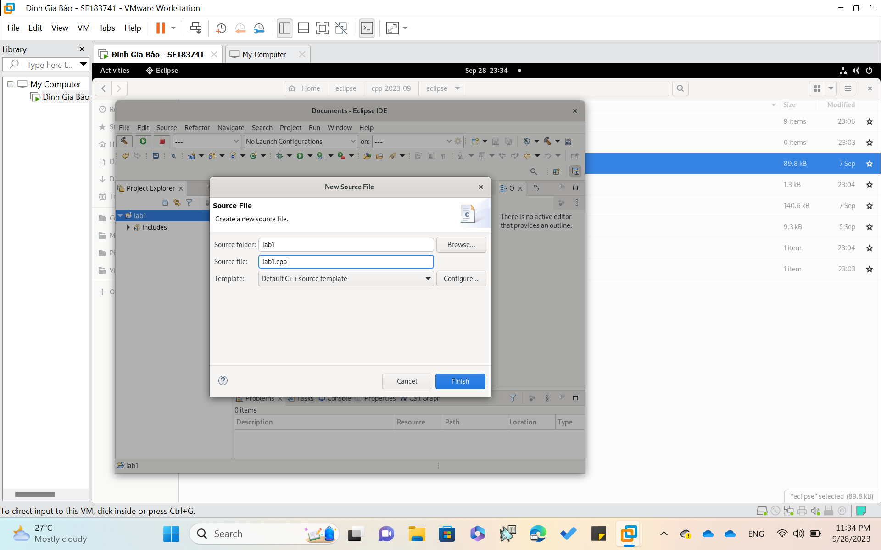

Set file name as ‘**.cpp**’

**Write Code**

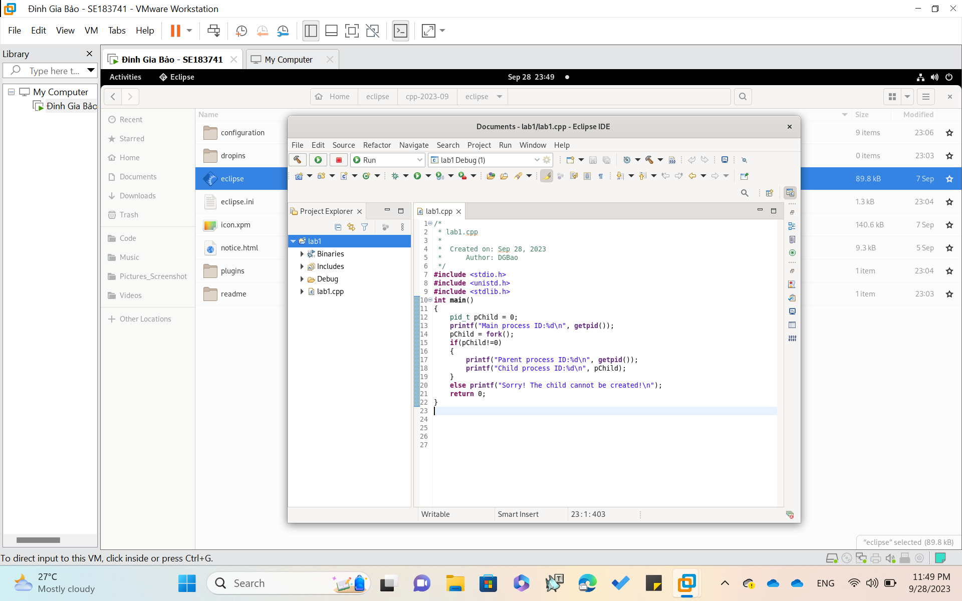

**Compile and Run**

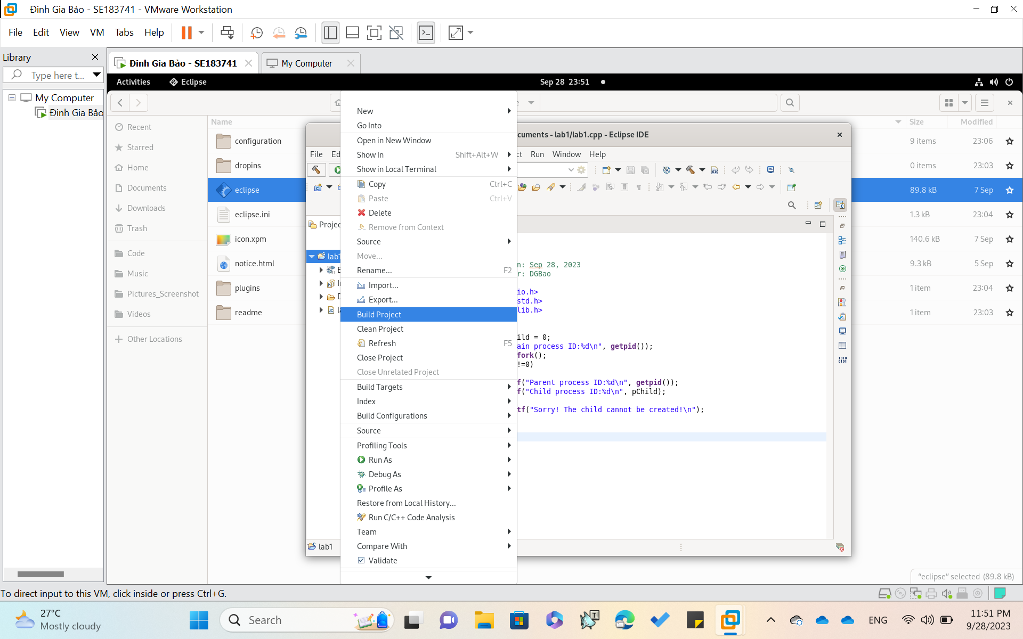

**Build Project**

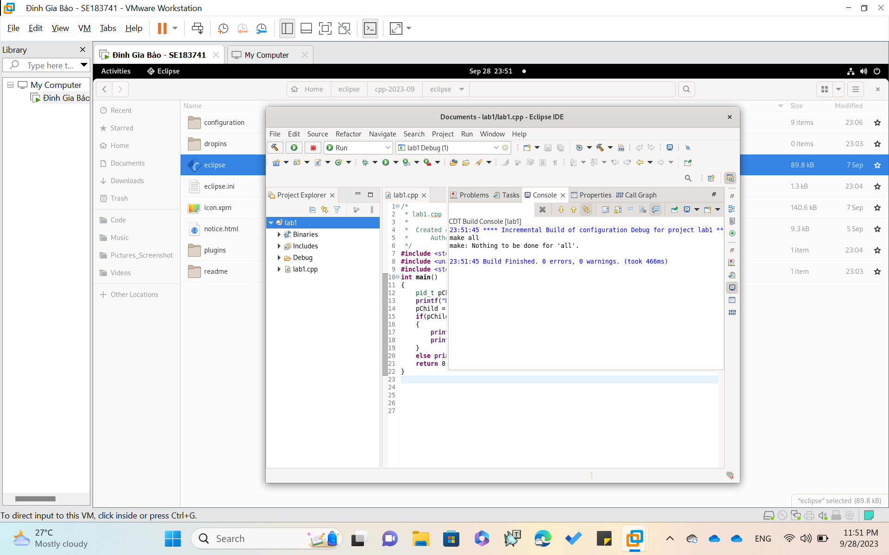

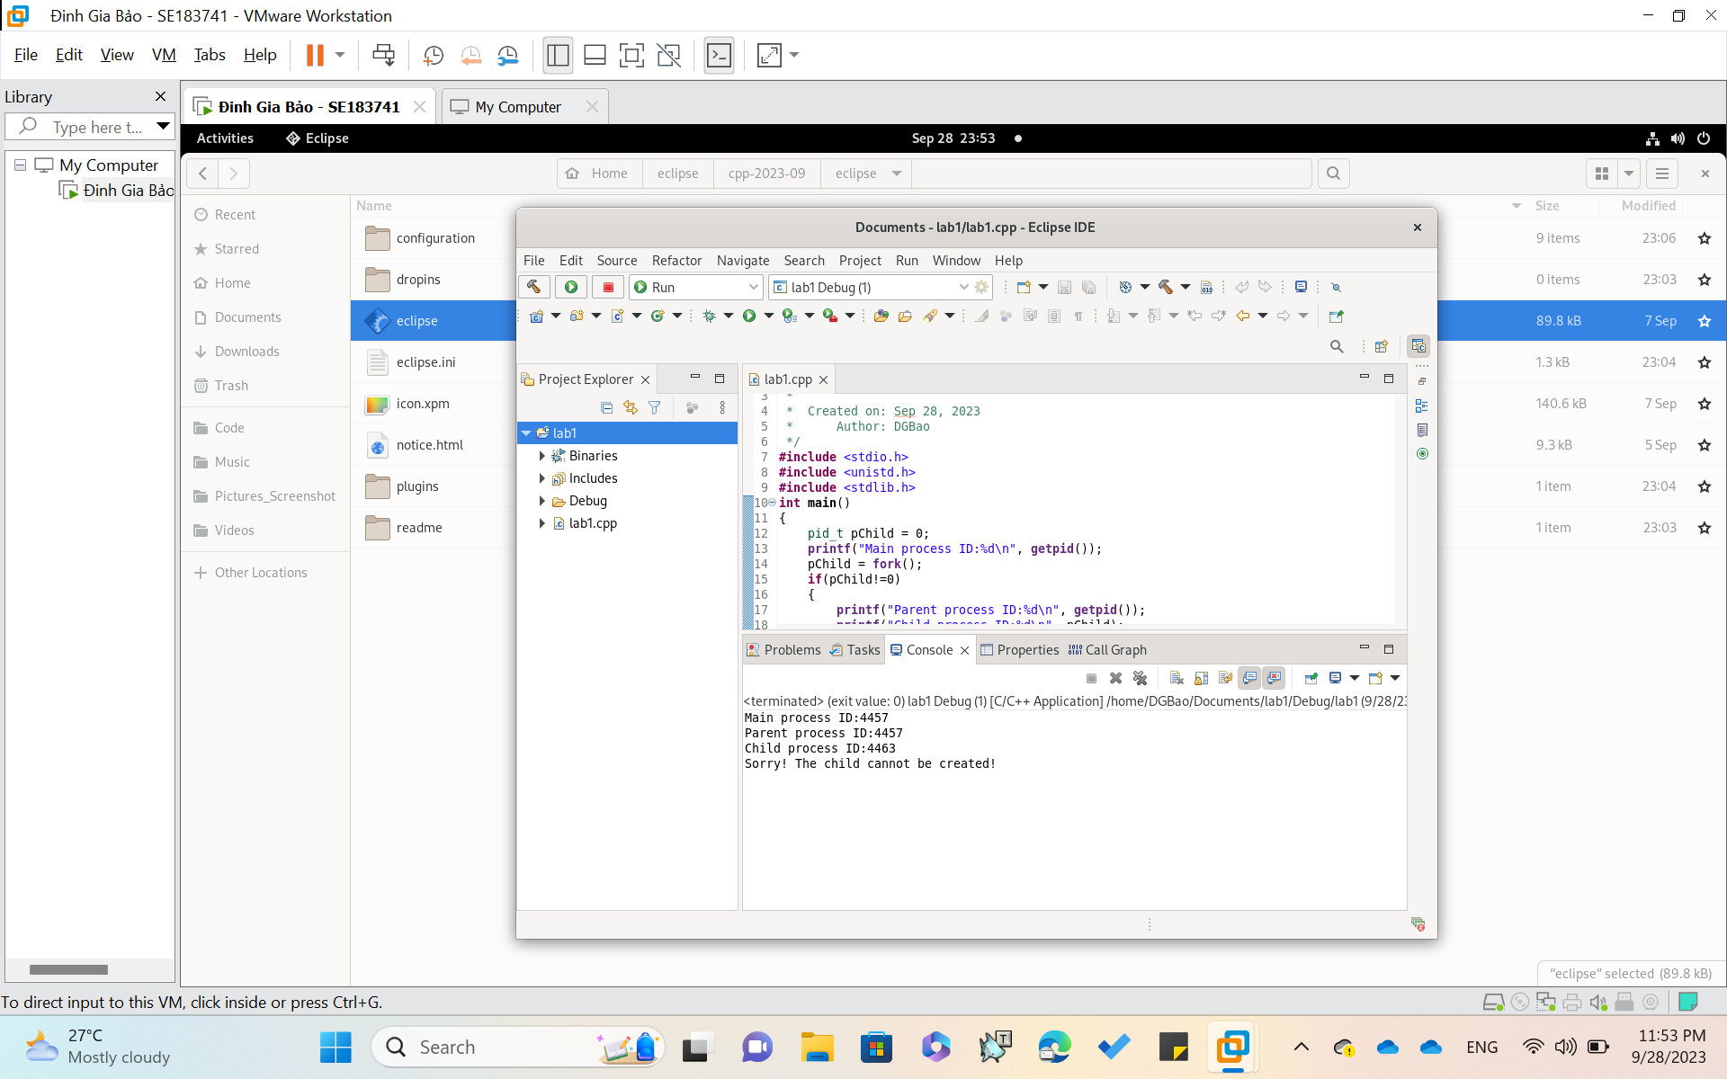

**RUN**

**Why the line 2 is printed   
( Use OS concepts about processes and multi-threading)**

*In your code, when the `fork()` function returns a non-zero value, it indicates that the child process could not be spawned. This typically occurs due to system memory limitations or an attempt to create an excessive number of child processes.*

*Virtual machines (VMs) have the capability to run multiple operating system instances on a single physical computer, which leads to savings in physical space, time, and management expenses. Additionally, VMs provide support for older legacy applications, which can significantly reduce the costs associated with migrating to a new operating system.*

**Run program outside the Eclipse**

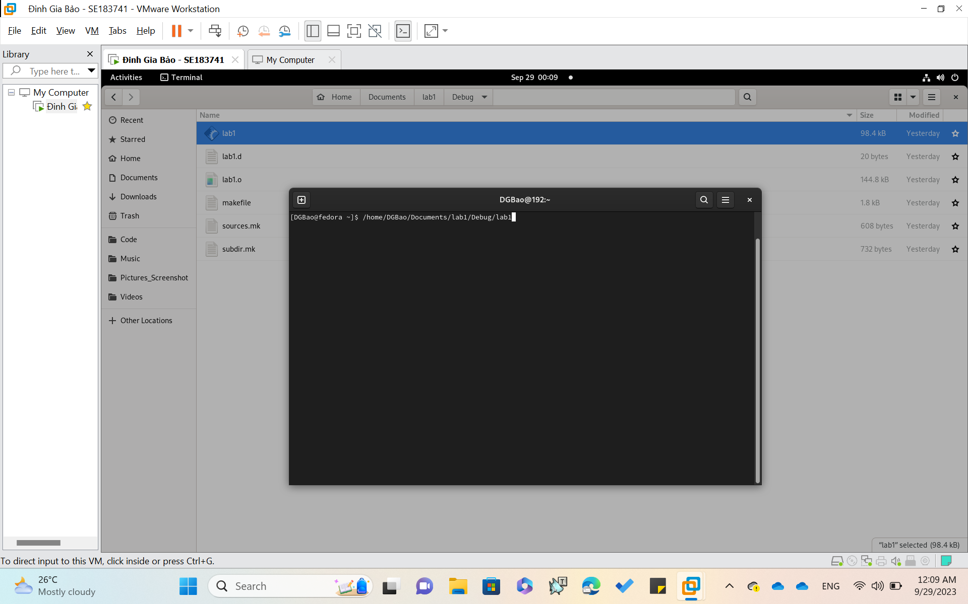

**Copy the path of the C project**

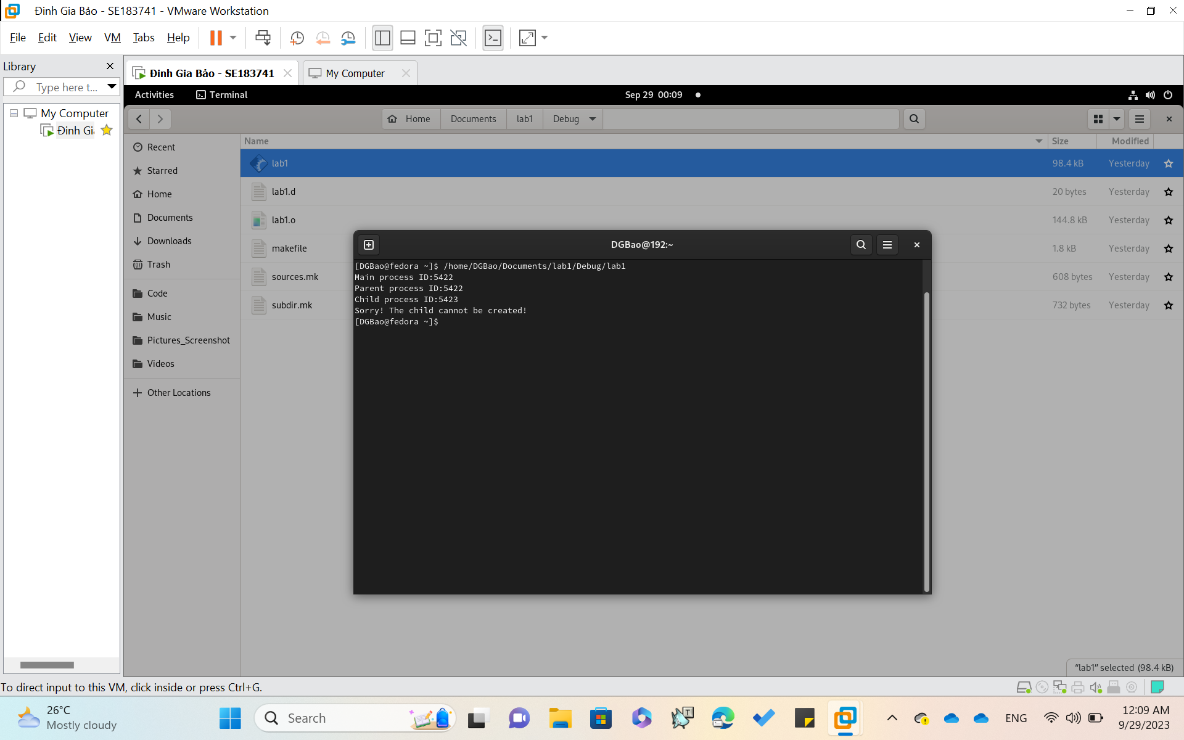

**CREATE OBJECT-ORIENTED PROJECT**

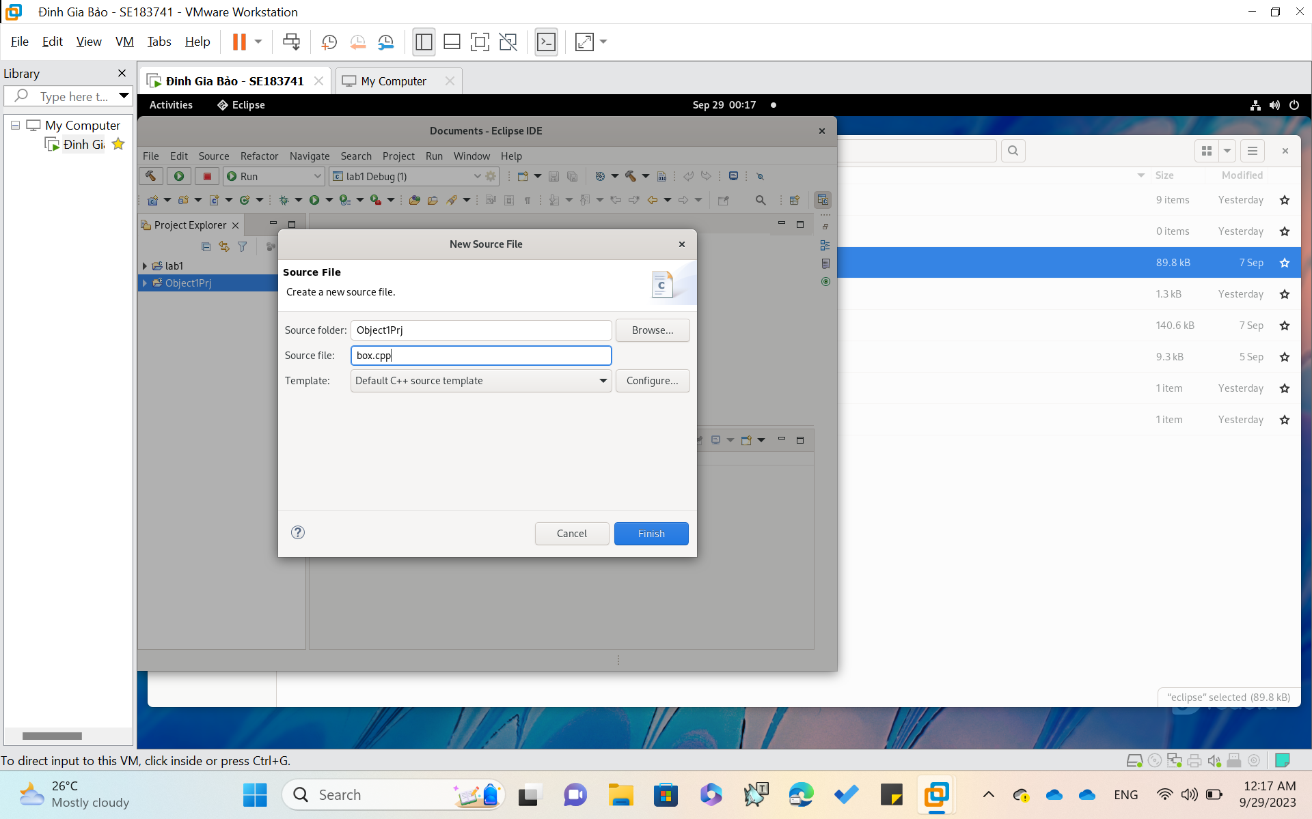

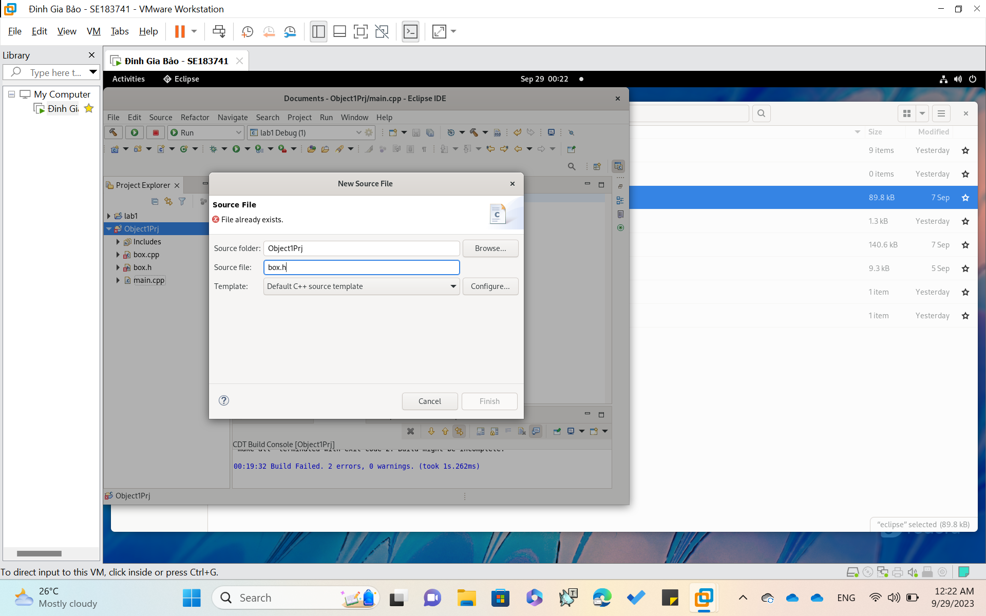

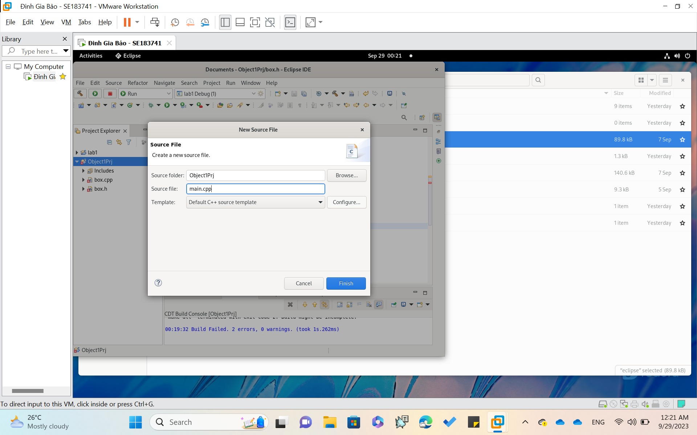

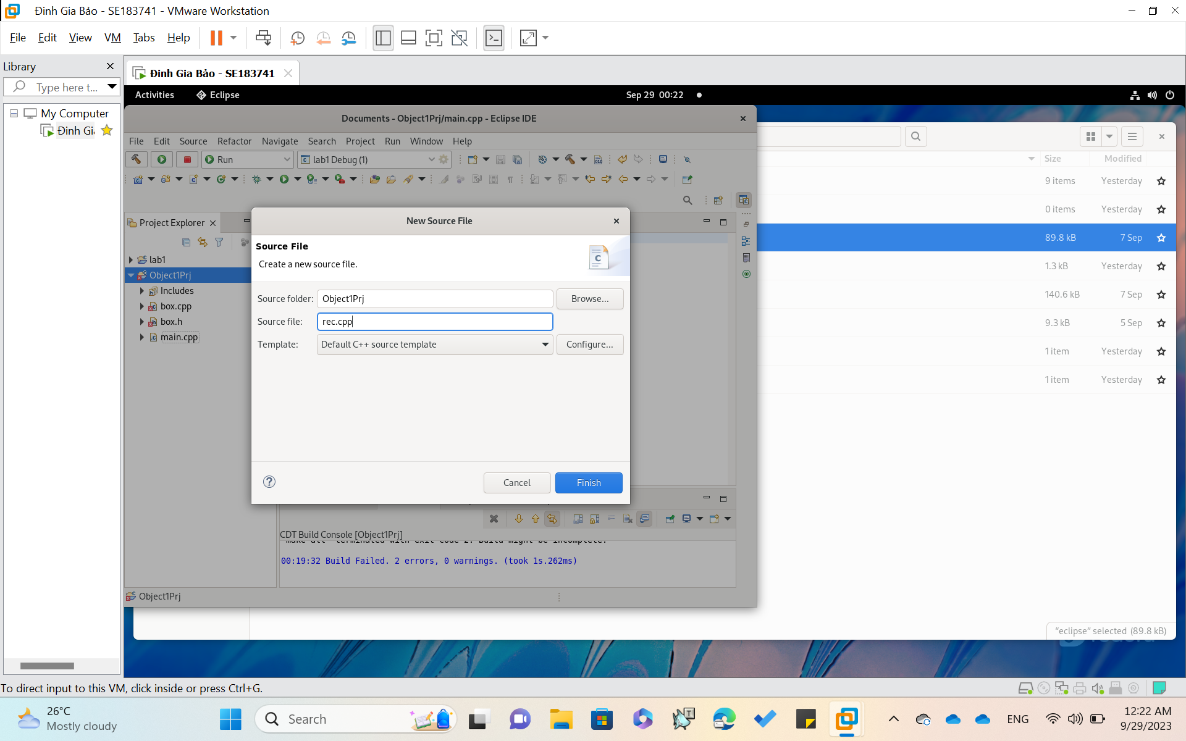

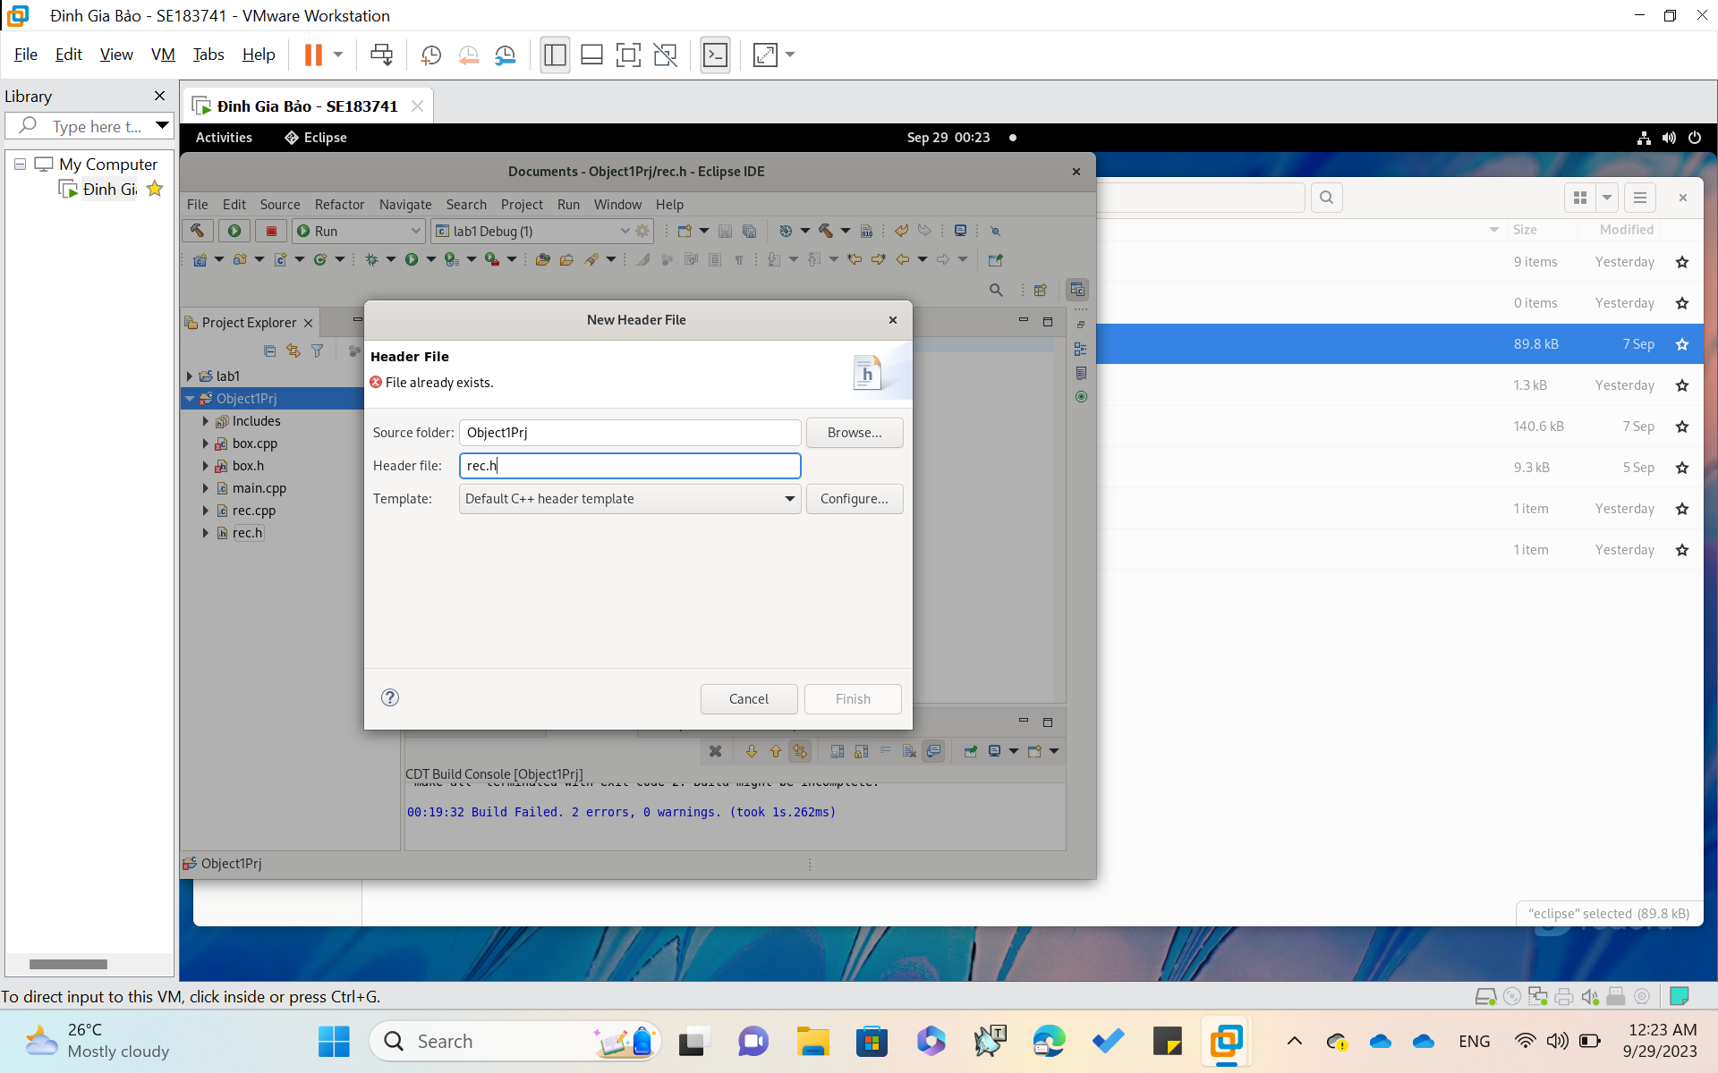

**After Create 5 classes like the Guide slide. Clean and Build**

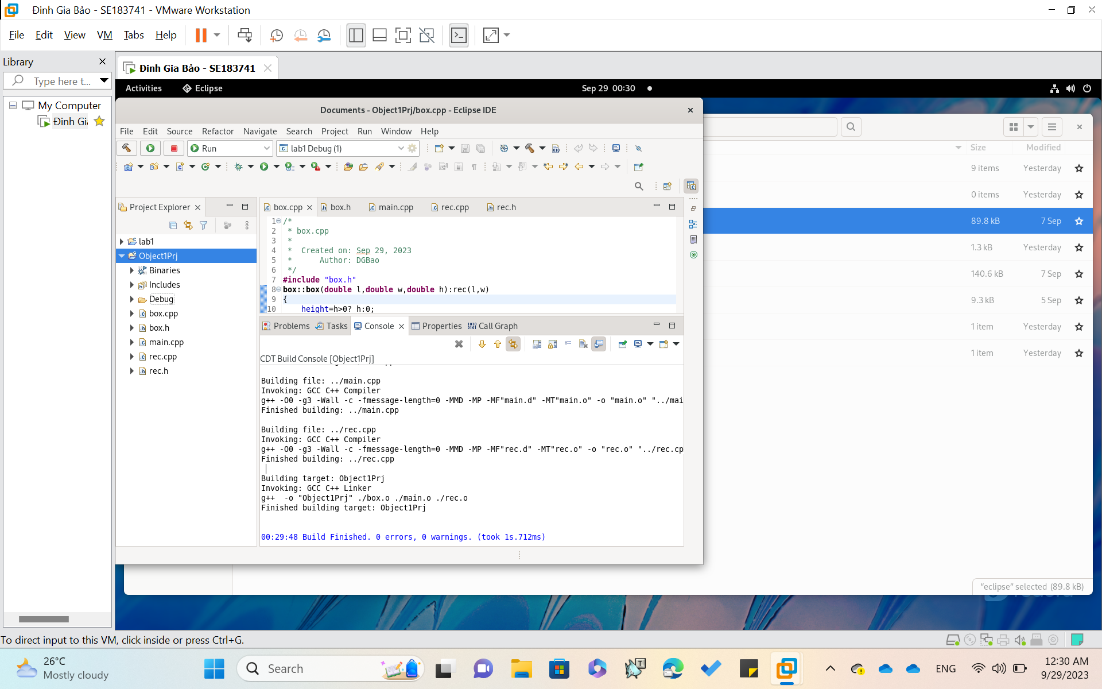

**Result:**

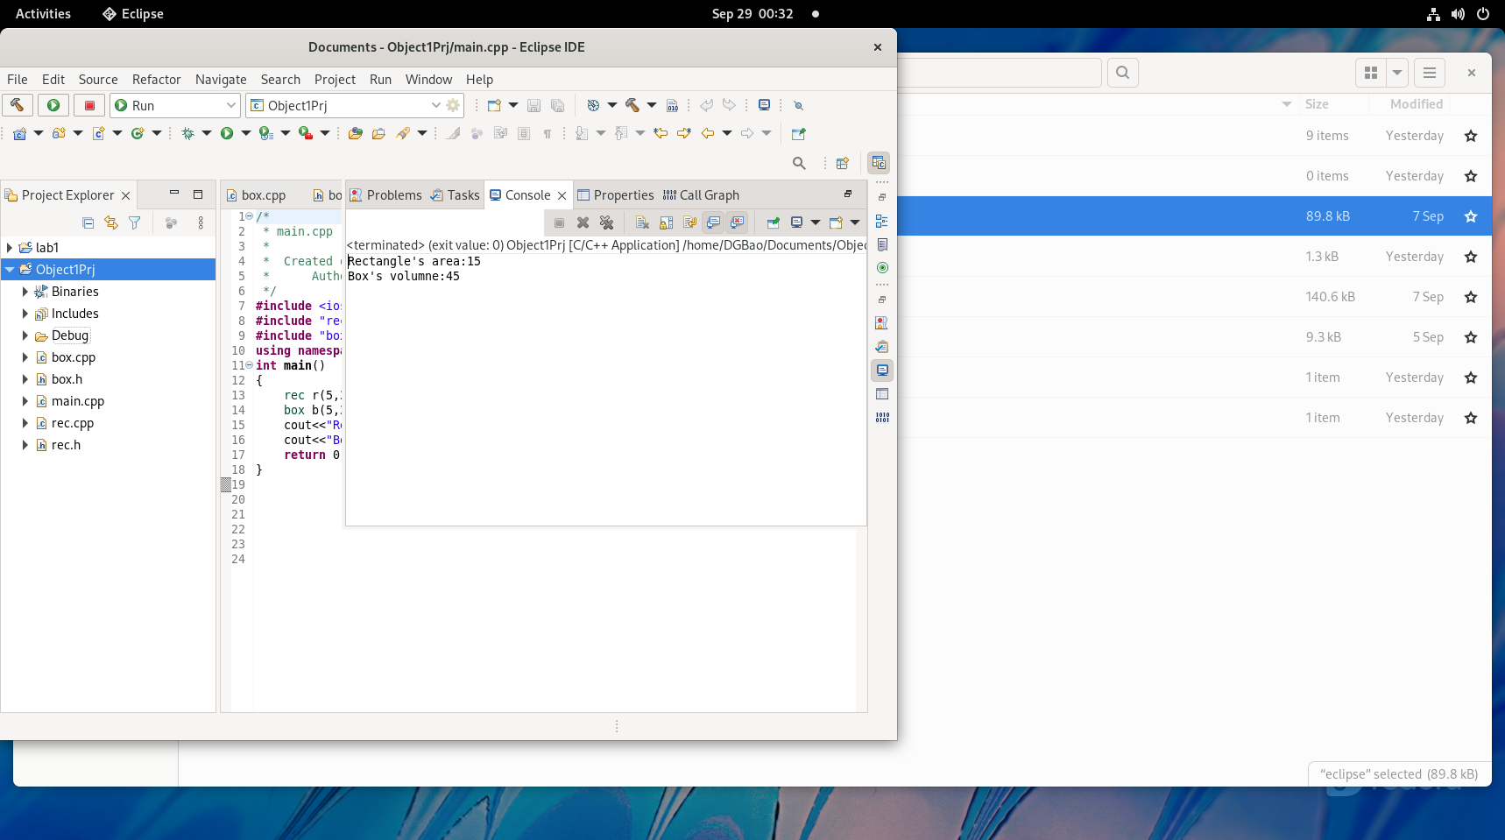

**End of Lab01**